

Application Development.

GYM Management system for Fitness Zone.



BEng (Hons) Software Engineering – Batch 08

**London Metropolitan University, BEng Software Engineering (top-up) Franchised Delivery at Esoft, Sri Lanka**

**Coursework Coversheet**

**Part 1 - To Remain with the Assignment after Marking**

|  |  |
| --- | --- |
| **Student ID: 17030187** | **Student Name**: I. A Milinda Kaushika |
| **Module Code: CS6004ES** | **Module Name:** Application Development |
| **Assignment number:** | **ESoft Module Leader:** |
| **Date set:** | **Date due:** |

**Guidelines for the Submission of Coursework**

1. Print this coversheet and securely attach both pages to your assignment. You can help us ensure work is marked more quickly by submitting at the specified location for your module. You are advised to keep a copy of every assignment.
2. Coursework deadlines are strictly enforced by the University.
3. You should not leave the handing in of work until the last minute. Once an assignment has been submitted it cannot be submitted again.

**Academic Misconduct**: **Plagiarism** and/or **collusion** constitute **academic misconduct** under theUniversity's Academic Regulations. Examples of academic misconduct in coursework: making available your work to other students; presenting work produced in collaboration with other students as your own (unless an explicit assessment requirement); submitting work, taken from sources that are not properly referenced, as your own. See: <http://www.londonmet.ac.uk/academic-misconduct/>By printing and submitting this coversheet with your coursework you are confirming that the work is your own.

**Group assignments only**: please enter student ID numbers and names for all group membersbelow.

|  |  |
| --- | --- |
| **Student ID:** | **Student Name:** |
| **Student ID:** | **Student Name:** |
| **Student ID:** | **Student Name:** |
| **Student ID:** | **Student Name:** |

|  |
| --- |
| ESoft Office Use Only:  Date stamp: work received |

**London Metropolitan University, BEng Software Engineering (top-up)**

**Franchised Delivery at Esoft, Sri Lanka**

**Coursework Coversheet**

Part 2 – Student Feedback

|  |  |
| --- | --- |
| **Student ID: 17030187** | **Student Name:** I. A Milinda Kaushika |
| **Module Code: CS6004ES** | **Module Name:** Application Development |
| **Assignment number:** | **ESoft Module Leader:** |
| **Date set:** | **Date due:** |

Strengths (areas with well-developed answers)

Weaknesses (areas with room for improvement)

Additional Comments

|  |  |
| --- | --- |
| **ESoft Module Lecturer:** | **Provisional mark as %:** |
| **ESoft Module Marker:** | **Date marked:** |

Contents

Abstract 2

Task - Introduction 6

Task - System Study 6

Task - Existing System 7

Task - Proposed System 8

Task - System Analysis & Design……………………………………………..…………………….…..…8

Task - Methodology Adopted…………………………………………………………………..12

Task - System Requirements……………………………………………………………..……..15

Task - Technologies used………………………………………………………….….…….……..16

Task - Cost Estimation………………………………….…………………………………..…..18

Task - System Design………………….…………………………………………..……………19

Task - ER Diagram……………………………………………………………………………...19

Task - Class Diagram…………………………………………………………………………...20

Task - User Interface designs…………………………………………………….……………..21

Task - Architecture and environment.....................................................................................….. 30

Task - Testing……………………….....................................................................................…...32

Task - Properties and method Information……....................................................................…....43

Task - User Manual……………………...…….....................................................................…...53

Task - Code……………………...…….................................................................................…...61

Task - System Maintenance & Evolution..............................................................................…...81

Task - Scope for further development…………………………..........................................................…...81

Task - Conclusion………………………….........................................................................................…...82

**Introduction to Project**

# 1.0 Fitness Zone (Gym Management System)

Fitness Zone is an easy-to-use Gym Management System. It helps you keep records of your members and their memberships, and allows easy communication between you and your members. Gym Trainer is also feature-packed, helping you in the management and growth of fitness zone. This has membership management system which helps to keep records of members and their membership details.

I have done a project on Gym Management and database management and transactions. This system is proposed to be an automate database management & transactions. This stores member, payroll, Trainer, Appointment, equipment and all reports information. It also provides the facility of search & advanced search for searching the records efficiently & immediately. This system provides data storing & report generation with graphical user interface (GU

# 1.1 System Study

It is always necessary to study and recognize the problems of existing system, which will help in finding out the requirements for the new system. System study helps in finding different alternatives for better solution. The project study basically deals with different operations and steps involved in generation of examination mark sheets.

* Data gathering.
* Study of existing system.
* Analyzing problem.
* Studying various documents.

Feasibility study for further improvements Following are the steps taken during the initial study: Initially, we collected all the information, which they wanted to store. Then we studied the working of the current system which is done manually. We noted the limitation of that system which motivated them to have new system. With the help of these documents we got basic ideas about the systems well as input output of the developed system.

**1.2 Existing System**

The gym system is working manually. The current system is time consuming and also it is very costly, because it involves a lot of paperwork. To manually handle the system was very difficult task. But now-a-days computerization made easy to work.

The following are the reasons why the current system should be computerized:

* To increase efficiency with reduced cost.
* To reduce the burden of paper work.
* To save time management for recording details of each and every member and employee.
* To generate required reports easily.

**Limitations of existing system:**

**Time consumption:**

As the records are to be manually maintained it consumes a lot of time.

**Paper work:**

Lot of paper work is involved as the records are maintained in the files & registers

**Storage requirements:**

As files and registers are used the storage space requirement is increased.

**Less reliable:**

Use of papers for storing valuable data information is not at all reliable.

**Accuracy:**

As the system is in manual there are lot many chances of human errors. These can cause errors in calculating mechanism or maintaining customer details.

**Difficulty in keeping new records:**

It is difficult for keeping all the new entries of members, their account and transaction details.

**1.3 Proposed System**

The proposed system is managed by the C#.Net, which are user friendly windows for every user and for maintaining the database Microsoft sql server is used.

The system proposed has many advantages.

1. The proposed system is highly secured.
2. It maintains report for all criteria and transactions.
3. Manages member information separately for all exercise and employee information separately for considering the requirements of gym.
4. Stores information about regular equipment details.
5. This system can run on any windows operating system.

**1.6 System Analysis & Design**

The way that is followed while carrying on with the development application is as follows.

**Phase I (Defining a problem)**

Defining a problem is one of the important activities of the project. The objective is to define precisely the business problem to be solved & thereby determined the scope of the new system. This phase consist of 2 main tasks. The 1st task within this activity is to review the organization needs that originally initiated the project. The 2nd task is to identify, at an abstract or general level, the expected capabilities of the new system. Thus, it helps us to define the goal to be achieved & the boundary of the system. A clear understanding of the problem will help us in building a better system & reduce the risk of project failure. It also specifies the resources that have to be made available to the project. Three important factors project goal, project bounds & the resource limits are sometimes called the project’s term of reference.

**Phase II (feasibility study):**

The first study aspect is whether the current project is technically feasible i.e. whether the project be carried out with the current equipment, existing software and available personnel. If new technology is required than what is the likelihood that it can be developed? The second study aspect is whether the project is economically feasible i.e. are there sufficient benefits in creating the system to make the cost acceptable. Are the costs of not creating the system so great that the project must be undertaken? The third study aspect is whether the project is operationally feasible or not i.e. whether the system will be used if it is developed and implemented? Project is worth developing only if it can meet institutions operating requirements. The feasibility study proposes one or more conceptual solutions to the problem set for the project. The objective in assessing feasibility is to determine whether a development project has a reasonable chance of success. It helps us to determine the input& output of the system. The following are the criteria that are considered to confirm the project feasibility.

**The following feasibility study was undertaken for the proposed system:**

**Technical feasibility:**

At first it’s necessary to check that the proposed system is technically feasible or not & to determine the technology and skill necessary to carry out the project. If they are not available then find out the solution to obtain them.

**Economic feasibility:**

While considering economic feasibility, it is checked in points like performance, information and outputs from the system. sql server is easy installing on windows operating system. The cost incurred to develop the system is freeware &does not incur the cost to the project.

**Social feasibility:**

Although generally there is always resistance, initially to any change in the system is aimed at reliving the work load of the users to extent the system is going to facilitate user to perform operations like calculating amounts and deductions, generating reports with less possible errors. Thus there is no reason to make system socially unfeasible.

**Operational feasibility:**

The operational feasibility is obtained by consulting with the system users. Check that proposed solution satisfies the user needs or not. There is no resistance from employee since new system is helpful. The existing system is manual system, while the new system is computerized and extremely user friendly.

**Software details of the proposed system:**

**Front End**:- Visual Studio (C#.Net).

**Back End** :- Microsoft SQL Server 2012.

**Phase III (System Analysis):**

The phase is detailed appraisal of the existing system. This appraisal includes how the system works and what it does. It also includes finding out more detail, what the problems with the system are and what user requires from the system or any new change in the system. The output of this phase results in detail model of the system. The model describes the system functions & data & system information flow. The phase also contains the detail set of user requirements are used to set objectives for new system.

**System study:**

It is always necessary to study and recognize the problems of the existing system, which will help in finding out the requirements for new system. System study helps in finding different alternatives for better solution. The project study basically deals with different operations and steps involved in generation of examination mark sheets. It includes:

* Data gathering.
* Study of existing system.
* Analyzing problem.
* Studying various documents.
* Feasibility study for further improvements.

**Following are the steps taken during the initial study:**

* We collected all the information, which they wanted to store.
* Then we studied the working of the current system which is done manually. We noted the limitations of that system which motivated them to have a new system
* Then we analyzed the format the reports generated by the system.

With the help these documents we got basic ideas about the system as well as input & output of the developed system.

**1.7 System Implementation**

**Methodology Adopted**

The spiral model, originally proposed by Boehm, is evolutionary software process model that couples the iterative nature of prototyping with the controlled and systematic aspects of the linear sequential model. It provides the potential for rapid development of incremental versions of the software. Using the spiral model, software is developed in a series of incremental releases. During early iterations, the incremental release might be a paper model or prototype. During later iterations, increasingly more complete versions of the engineered system are produced. A spiral model is divided into a number of framework activities, also called task regions.

Typically, there are between three and six task regions. Figure depicts a spiral model that contains six task regions:

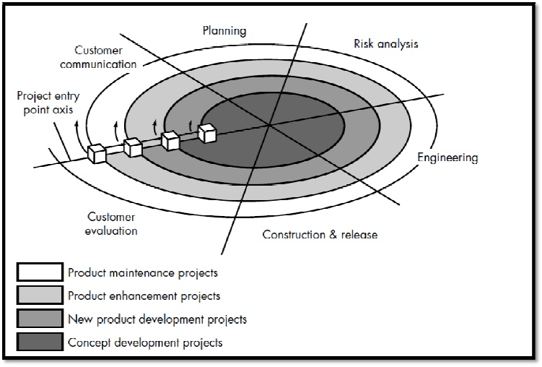

* **Customer communication**

Tasks required establishing effective communication between developer and customer.

* **Planning**

Tasks required defining resources, timelines, and another project related information.

* **Risk analysis**

Tasks required to assess both technical and management risks.

* **Engineering**

Actual development and testing if the software takes place in this phase.

* **Construction and release**

Tasks required constructing, testing, installing, and providing user support (e.g., documentation and training).

**Customer evaluation**

Tasks required obtaining customer feedback based on evaluation of the software representations. Created during the engineering stage and implemented during the installation stage. Each of the regions is populated by a setoff work tasks, called a task set, that are adapted to the characteristics of the project to be undertaken. For small projects, the number of work tasks and their formality is low. For larger, more critical projects, each task region contains more work tasks that are defined to achieve a higher level of formality. In all cases, the umbrella activities (e.g. software configuration management and software quality assurance) noted is applied. As this evolutionary process begins, the software engineering team moves around the spiral in a clockwise direction, beginning at the center. The first circuit around the spiral might result in the development of a product specification; subsequent passes around the spiral might be used to develop a prototype and then progressively more sophisticated versions of the software. Each pass through the planning region results in adjustments to the project plan. Cost and schedule are adjusted based on feedback derived from customer evaluation. In addition, the project manager adjusts the planned number of iterations required to complete the software. Unlike classical process models that end when software is delivered, the spiral model can be adapted to apply throughout the life of the computer software. An alternative view of the spiral model can be considered by examining the project entry point axis, also shown in Figure. Each cube placed along the axis can be used to represent the starting point for different types of projects.

Because software evolves as the process progresses, the developer and customer better understand and react to risks at each evolutionary level. The spiral model uses prototyping as a risk reduction mechanism but, more important, enables the developer to apply the prototyping approach at any stage in the evolution of the product. It maintains the systematic stepwise approach suggested by the classic life cycle but incorporates it into an iterative framework that more realistically reflects the real world. The spiral model demands a direct consideration of technical risks at all stages of the project and, if properly applied, should reduce risks before they become problematic.

**1.8 System Requirements**

**Hardware and Software Specification:**

**HARDWARE:**

* Minimum 5 GB HDD space2
* 64 based processor
* 1Gb RAM
* Printer (any)
* Power Supply For Backup

**SOFTWARE:**

* Microsoft Windows 7, 8
* Visual Studio 2014 (C#.Net)
* MS SQL server management studio 2012

Visual C#.Net is great! It’s an easy, economical and fast application development tool; it’s a good prototyping tool and developer’s love using it. Like any high-level programming language, Visual C#.Net lets the programmer write really awful programs, and with C#.Net, you can screw up more easily and faster than ever! Important business logic can be attached to GUI widgets rather than placed in reusable objects, making it hard to share and reuse code.

**Microsoft SQL Server:**

Microsoft SQL Server may be a relational database management system, or DBMS, that supports a large kind of dealing process, business intelligence and analytics applications in company IT environments. It's one among the 3 market-leading database technologies, alongside Oracle database and IBM's DB2.

**1.9 Technologies used**

**Here is some discussion about visual C#.**

C# is designed to work with Microsoft's Net platform. Microsoft's aim is to facilitate the exchange of information and services over the Web, and to enable developers to build highly [portable](http://searchstorage.techtarget.com/definition/portability) applications. C# simplifies programming through its use of Extensible Markup Language ([XML](http://searchsoa.techtarget.com/definition/XML)) and Simple Object Access Protocol ([SOAP](http://searchsoa.techtarget.com/definition/SOAP)) which allow access to a programming [object](http://searchsoa.techtarget.com/definition/object) or [method](http://searchcio-midmarket.techtarget.com/definition/method) without requiring the programmer to write additional code for each step. Because programmers can build on existing code, rather than repeatedly duplicating it, C# is expected to make it faster and less expensive to get new products and services to market.

**A) Some features of Visual C#**

Like the basic programming language, Visual c# was designed to be easily learned and used by beginner programmers. The language not only allows programmers to create simple GUI applications, but can also develop complex applications. Programming in c# is a combination of visually arranging components or controls on a form, specifying attributes and actions of those components, and writing additional lines of code for more functionality. Since default attributes and actions are defined for the components, a simple program can be created without the programmer having to write many lines of code. Performance problems were experienced by earlier versions, but with faster computers and native code compilation this has become less of an issue

Forms are created using drag-and-drop techniques. A tool is used to place controls (e.g., text boxes, buttons, etc.) on the form (window).Controls have attributes and event handlers associated with them. Default values are provided when the control is created, but may be changed by the programmer. Many attribute values can be modified during run time based on user actions or changes in the environment, providing a dynamic application. For example, code can be inserted into the form resize event handler to reposition a control so that it remains centered on the form, expands to fill up the form, etc. By inserting code into the event handler for a key press in a text box, the program can automatically translate the case of the text being entered, or even prevent certain characters from being inserted.

**B) Microsoft SQL Server as the backend:**

Microsoft SQLis a database package generally, used to design database applications. Microsoft SQL is used in this project for following reasons**:**

* Microsoft SQLable to store large data.
* It’s DBMS.
* Creating relationship is not a complex task.
* Microsoft SQLcan execute any valid SQL query.
* It provides all necessary forms of data types.
* Microsoft SQLhas good connectivity with visual C#.Net.

**1.10 Cost and benefit analysis**

**1.10 Cost Estimation**

Cost required for the project is to install the software and hardware requirements. Software may include installing Microsoft Sql on the system. Cost due to the time taken for completion of the project which can be around one month.

**1.11 Benefit Analysis**

Due to the introduction of this system the cost of handling the system is reduced. The cost mainly includes the charges for registry maintenance, receipt books, files, etc. To reduce the costs the new system was proposed. Positive aspects of the designed system which contributed to the benefit analysis are fast and easy storage of all information. It was also easy to retrieve any required details as fast as possible. There is no need for maintaining receipt books. The new system is very beneficial than because the system is fully automated.

**System Design**

**1.12 Database design**

**1.12 Entity Relationship Diagram**

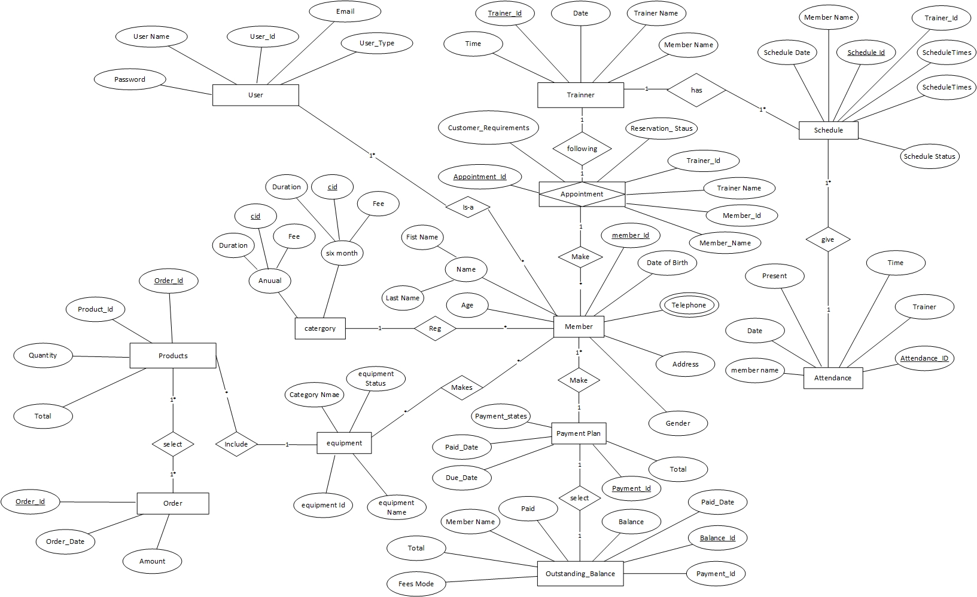

**1.13 Class Diagram**

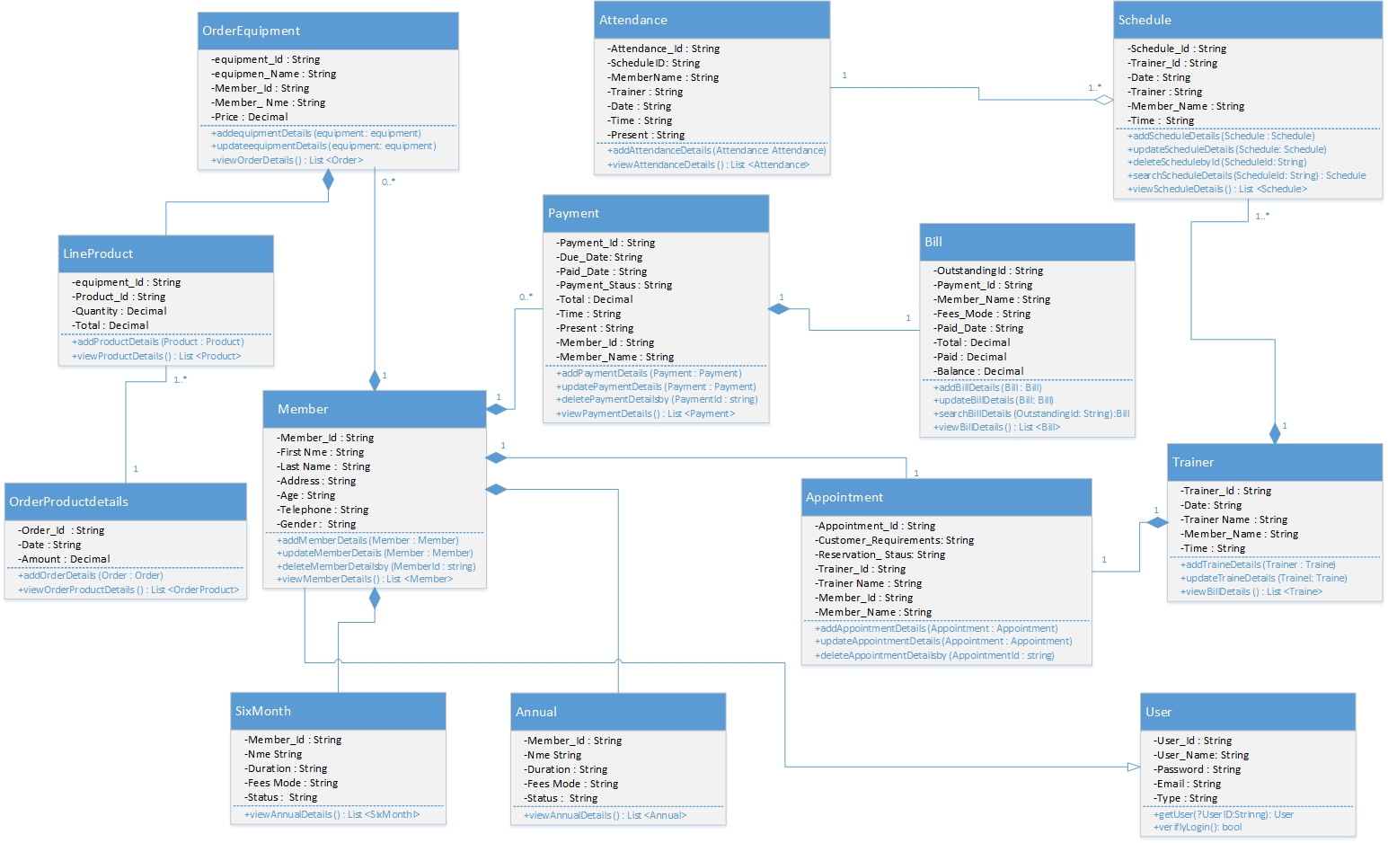

**Sample user Interface designs**

**1.14 Basic main menu design**

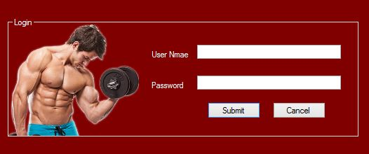

Login design

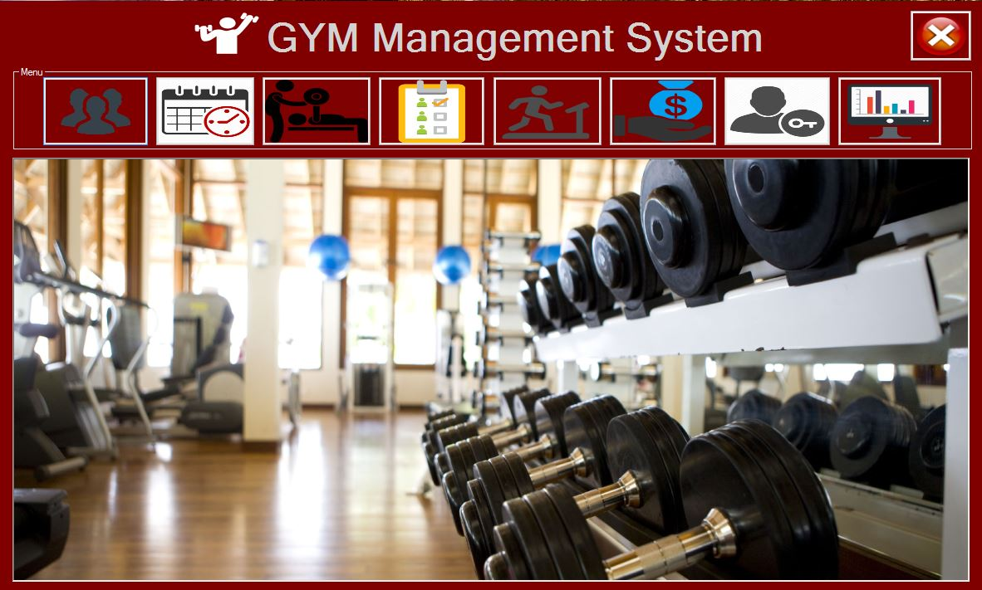

Main menu design

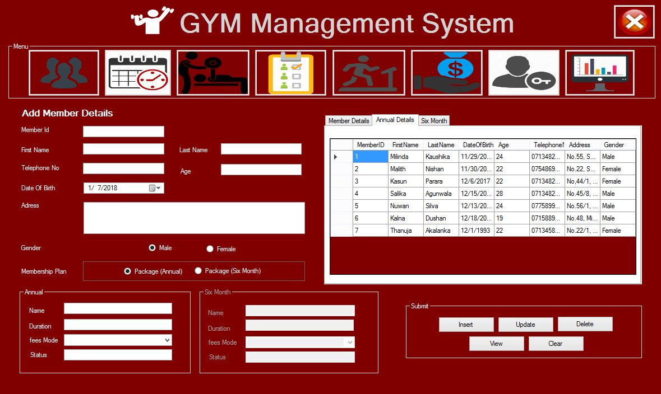

Member Registration Interface design

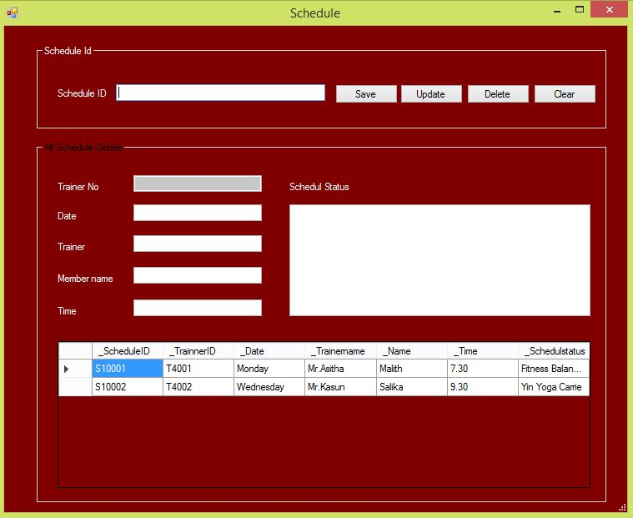

Schedule Interface design

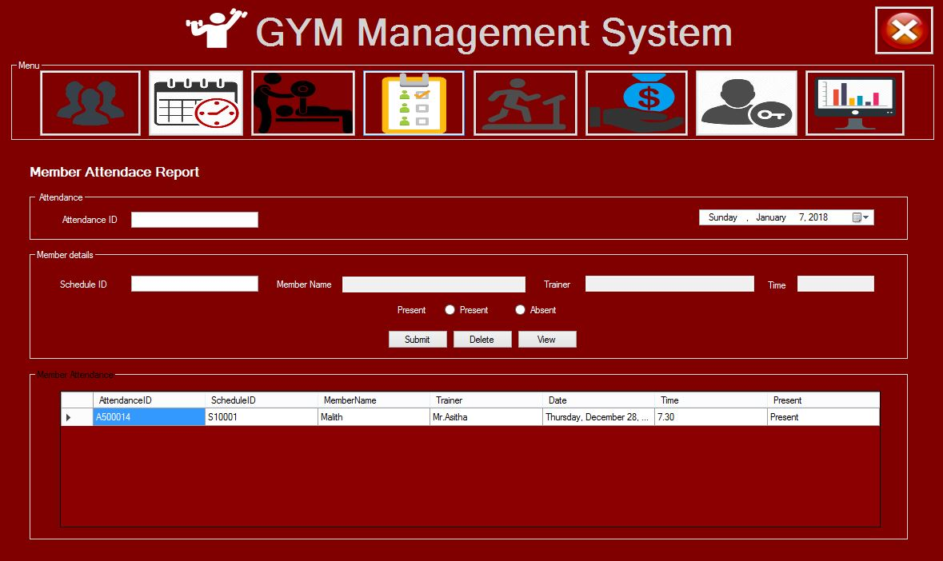

Member Attendance Interface design

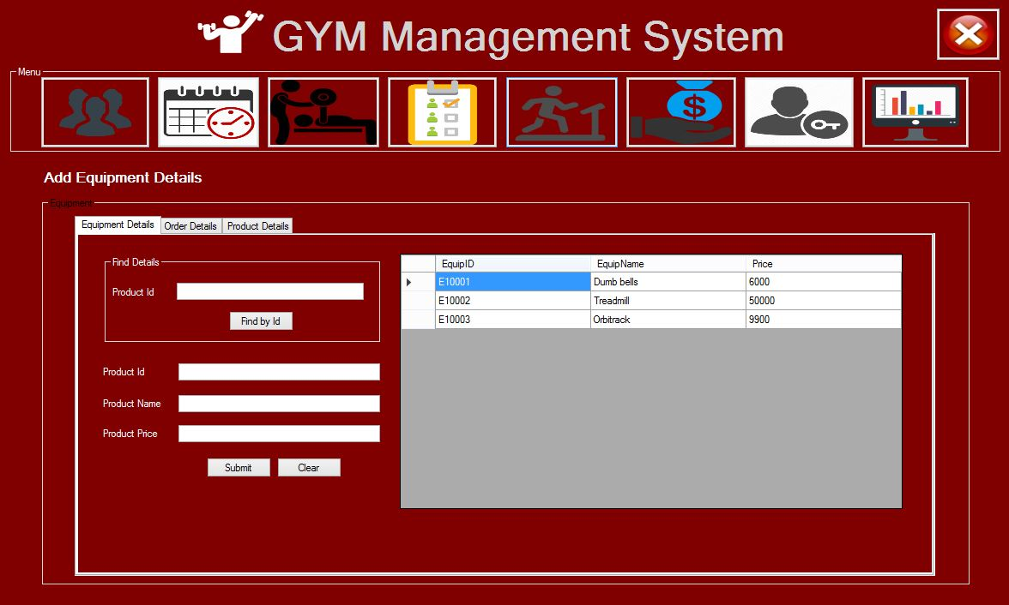

Equipment Interface design

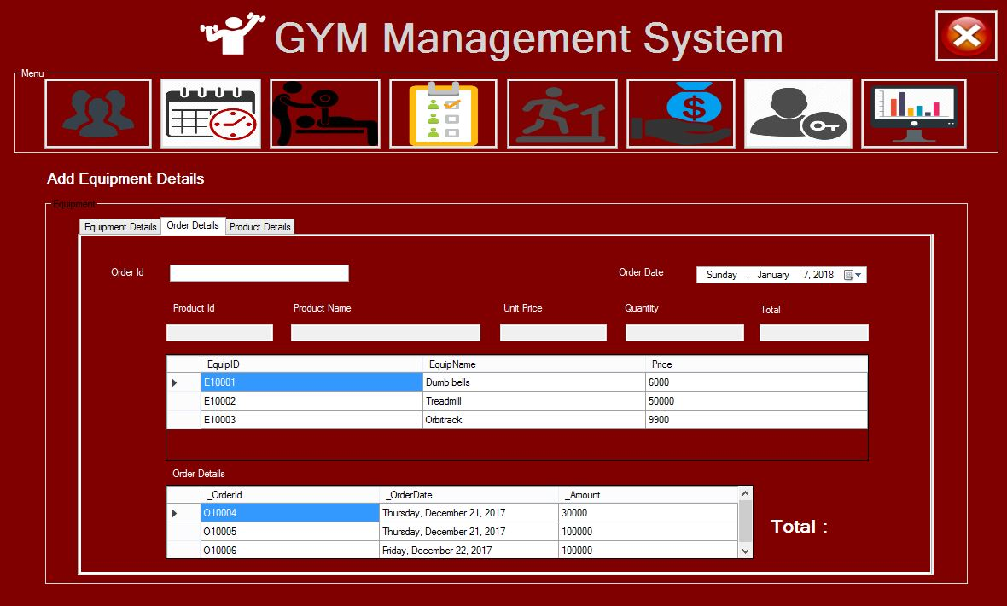

Order Equipment Interface design

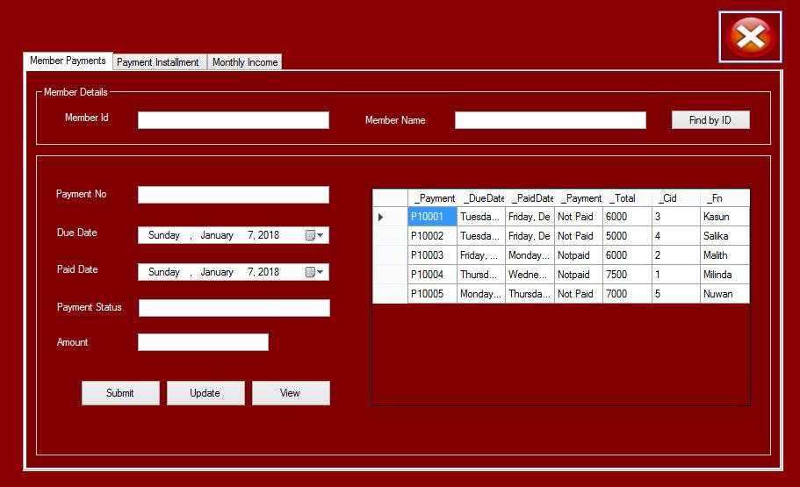

Member Payment Interface design

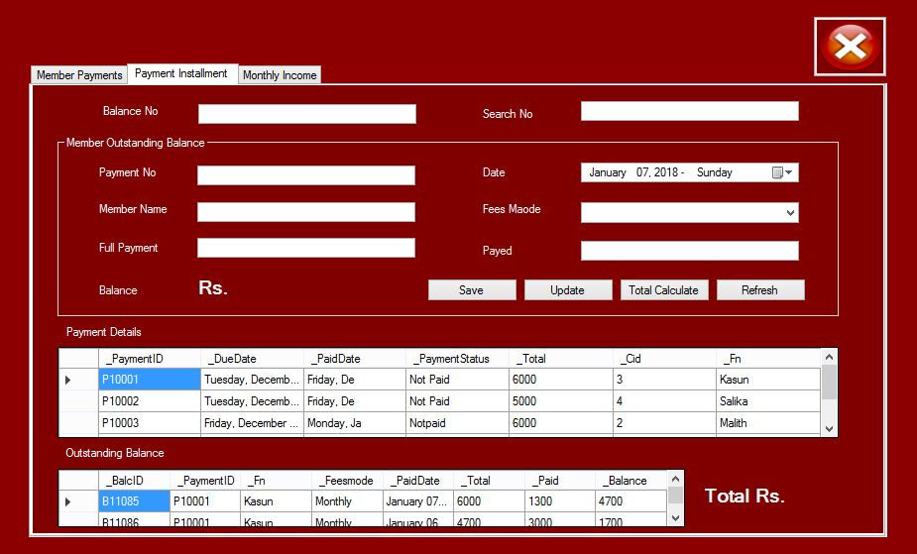

Member Payment Balance Interface design

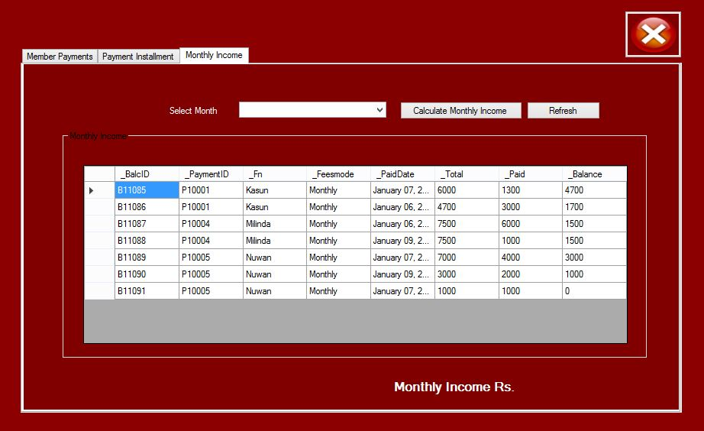

Monthly Income Interface design

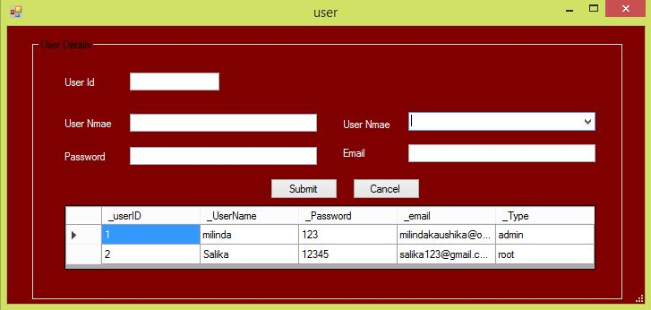

Member Login Interface design

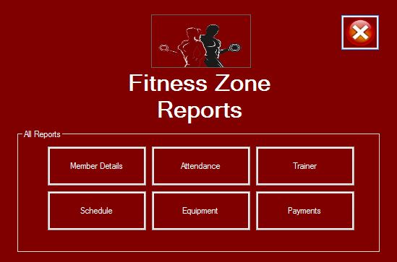

Report Interface design

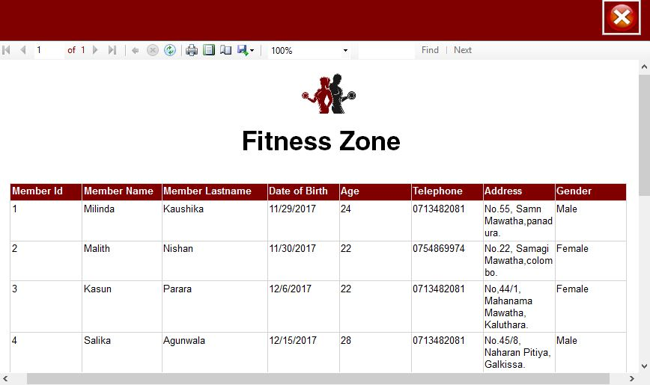

Member Registration Report Interface design

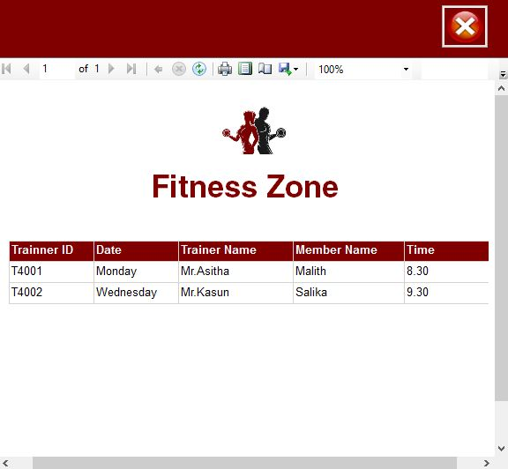

Trainer Report Interface design

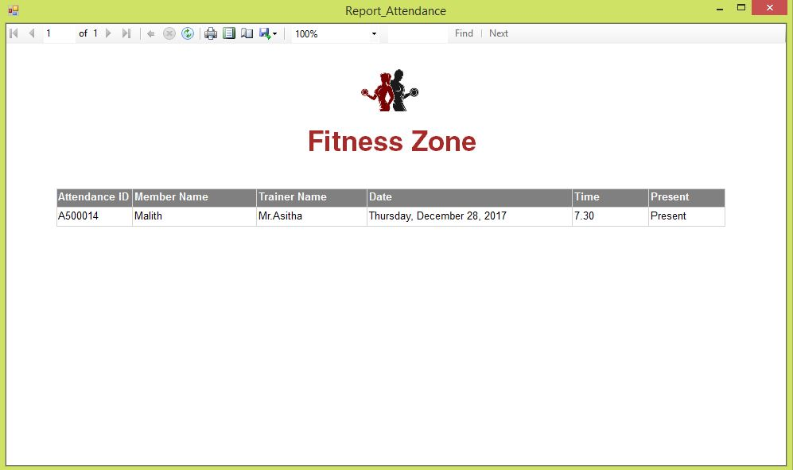

Member Attendance Report Interface design

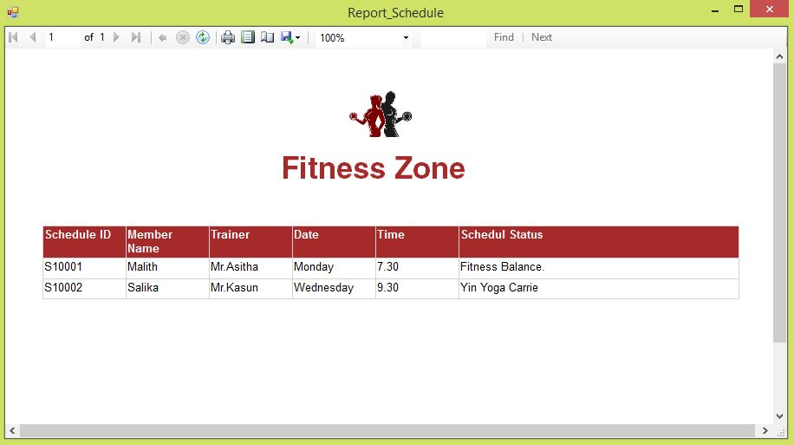

Member Schedule Report Interface design

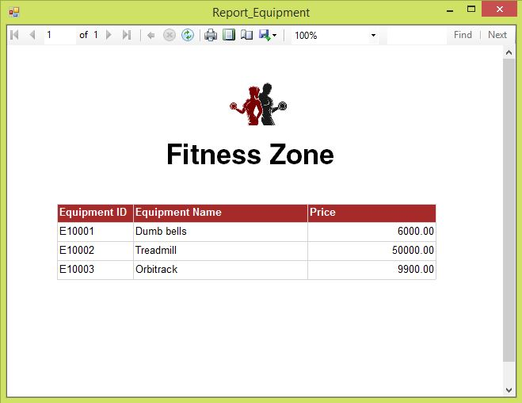

Member Equipment Report Interface design

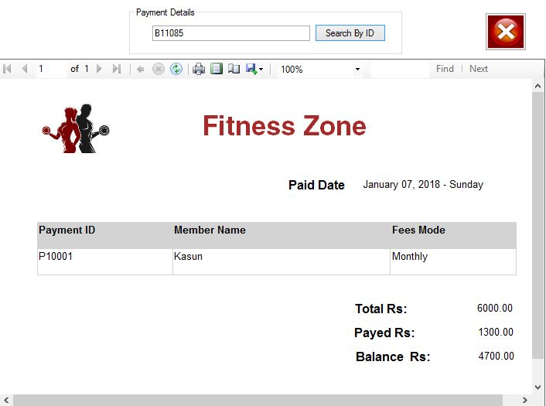

Member Payment Report Interface design

**1.15 Implementation**

**1.15 Development Architecture and Environment.**

**System development architecture**

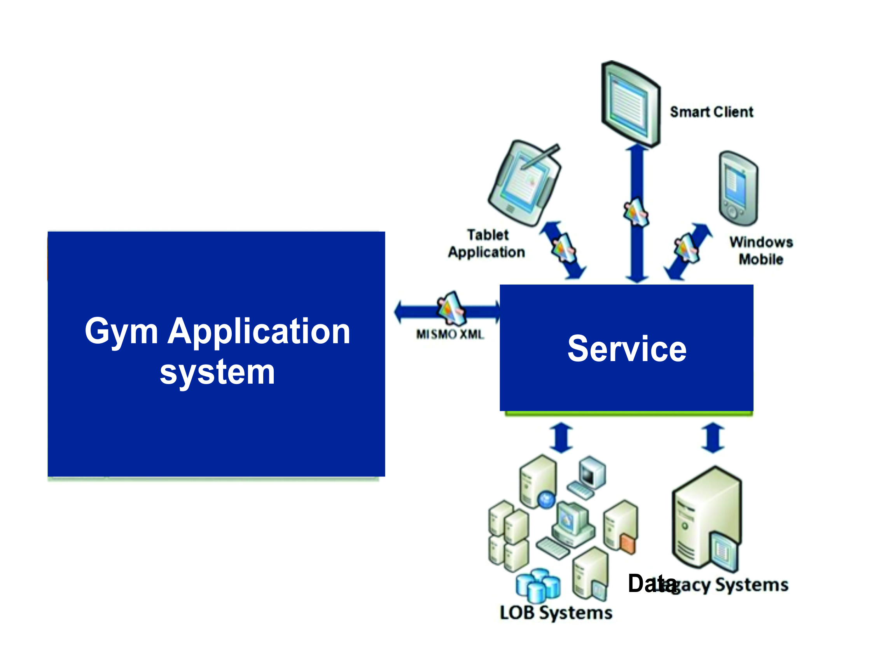

Following table represents the sub components of the AL Gym management system which refer to each tier in three tier architecture.

**System sub components which refer to each tier in three tier architecture**

|  |  |  |
| --- | --- | --- |
| **Database** | **Application** | **Presentation** |
| **Database:**  Gym | **Entity classes:**  - Member.cs  - Annual.cs  - six_month.cs  - Attendance.cs  - Equipment.cs  - LineProduct.cs  - MemPayments.cs  - Paymentbalance.cs  - Order.cs  - schedule.cs  - User.cs  **Data classes:**  - DBEstablish.cs  - SystemDAL.cs | **Interfaces:**  Form_User.cs  Form_Main.cs  Form_Member.cs  Form_ Payment.cs  Form_ Report_Attendance.cs  Form_ Report_Equipment.cs  Form_ Report_Schedule.cs  Form_ Report_Trainer.cs  Form_ Report_member.cs |

**Host Environment (Development environment)**

|  |  |  |
| --- | --- | --- |
| **Host environment - software Host environment - Software** | | |
| **1** | **Operating system** | Windows 8 or 9 Professional Edition |
| **2** | **Programming language** | C#.NET |

**1.16 Methodology used for Testing**

**1.16 Testing**

System testing is designed to uncover the weaknesses that were not founding earlier test. In the testing phase, the program is executed with the explicit intention of finding errors. This includes forced system failures and validation of the system, as its user in the operational environment will implement it. For this purpose test cases are developed. When a new system replaces the old one, such as in the present case, the organization can extract data from the old system to test them on the new. Such data usually exist in sufficient volume to provide sample listings and they can create a realistic environment that ensures eventual system success. Regardless of the source of test data, the programmers and analyst will eventually conduct four different types of tests.

**Integration Testing**

The integration is the next important concept that highlights in the testing scenario. Integration testing can be performed in different strategies. One of them is the Big Bang testing in which one could first test all of a system’s modules separately and then whole systems at once. But here we proceed abruptly from the module testing and the integration testing disappears. Another alternative is the Incremental Testing. With the Incremental testing there are many advantages. We can start the integration as soon as reasonable subsets of modules have been developed. It is easier to localize errors incrementally. The partial aggressions of modules often constitute important subsystems that can have autonomy with these testing. The need for stubs and drivers can be reduced.

There are two approaches to the Incremental Testing. They include Bottom-up and Top-down aggregations. The former means starting aggregation and testing from leaves of the module charts. The latter means starting from the top-level modules and substitute for higher-level modules. In our project we have used the top-down approach of incremental testing. Top-down integration is an incremental approach to the construction of programs structure. Modules are integrated by moving downward through the control hierarchy, beginning with the main control module that is the basic connectivity module in our project. Test is done on each module. The top down integration strategy verifies major control or decision points. In the beginning of the integration phase dummy frames were selected as stubs to ensure that the data flow occurred through the correct hierarchical structure. Later the actual module replaces these stubs.

**Various Testing Methods**

Unit testing focuses verification efforts on the smallest unit of the software design, the module. This is also known as Module Testing. The modules are tested separately. This testing is carried out during programming stage itself.

**Validation Testing**

Validation testing can be defined in many ways but a simple definition is that validation succeeds when the software functions in a manner that can be reasonably expected by the users .After validation test has been conducted one of the two possible conditions exists1. The function or the performance characteristics confirm to specification and are accepted.2. A deviation from specification is uncovered and a deficiency lists created.

**Output Testing**

After performing the validation testing the next step is output testing of the proposed system since no system is useful if it does not produce the required output in the specific format. The outputs generated or displayed by the system under consideration are tested by asking the users about the formats required by them.

**Quality Assurance Methodologies**

Quality assurance is a planned and systematic of all actions necessary to provide adequate confidence that the item or product confirms to established technical requirements. The purpose of software quality assurance group is to provide assurances that the procedures, tools and techniques used during product development and modification and adequate to provide desired level of confidence in the work products. Often, software quality assurance personnel are organizationally distinct from software development group. Preparation of a Software Quality Assurance

Plan for each software products is primary responsibility of software quality assurance group.

**System verification and validation**

System verification and validation is done to check the quality of the software in simulated and live environment. A number of different transactions are used to perform verification. Validation is the process of demonstrating that the implemented software does satisfy the system requirements. One aspect of software validation is to statistically analyze the program without resorting tactual execution. The system validation done in such-a-way that the system response time will not cause any hardship to the user.

**White Box Testing**

White box testing is a test case design method that uses the control structure of the procedural design to derive test cases. Using white box testing methods, we can derive test cases that

* Guarantee that all independent paths within a module have been exercised at least once.
* Exercise all logical decisions on their true and false sides
* Execute all loops at their boundaries and within their operational bounds
* Exercise internal data structures to ensure their validity.

**Black Box Testing**

Black box testing methods focus on the functional requirements if the software. That is, black box testing enables us to derive sets of input conditions that will fully exercise all functional requirements of the program. Black box testing attempts to find errors in following categories:

* Incorrect or missing functions.
* Interface errors.
* Errors in data structures or external database.
* Performance errors Initialization and termination errors.

**Text plan execution and test results**

**Test case 1 execution**

* **Test case 1 – Login Information.**

|  |  |  |  |  |  |  |  |
| --- | --- | --- | --- | --- | --- | --- | --- |
| **Test Case #** | **Condition** | **Test Execution step** | **Expected Result** | **Test Result** | **Date Tested** | **Tester** | **Comments** |
| TC0001 | Login to the system using invalid credentials | 1. Enter "milinda1" to the Username 2. Enter "1235" to the Password 3. Press "Login" button | system should give an error saying input username  or password is wrong | F | 6-Oct-2017 | M |  |
| TC0002 | Login to the system using valid credentials | 1. Enter "milinda" to the Username 2. Enter "123" to the Password 3. Press "Login" button | Successful login for Dashboard. | P | 6-Oct-2017 | M |  |

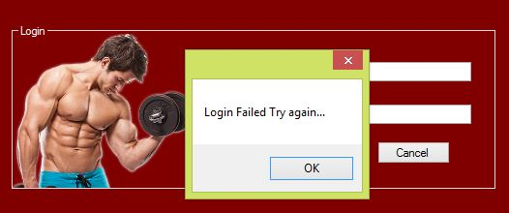

**Test case 2 execution**

* **Test case 2 – Member Information.**

|  |  |  |  |  |  |  |  |
| --- | --- | --- | --- | --- | --- | --- | --- |
| **Test Case #** | **Condition** | **Test Execution step** | **Expected Result** | **Test Result** | **Date Tested** | **Tester** | **Comments** |
| TC0003 | Try to save the form without entering any field | 1. Go to Member Registration form 2. Press Save button | System should give an warning or it should show the missing fields. | F | 6-Oct-2017 | M |  |
| TC0004 | Save all required fields and cross check with database | 1. Open Member registration form 2. Fill out all the required fields 3. Press Save & Create Account. | System should save all required fields in the database. | P | 6-Oct-2017 | M |  |

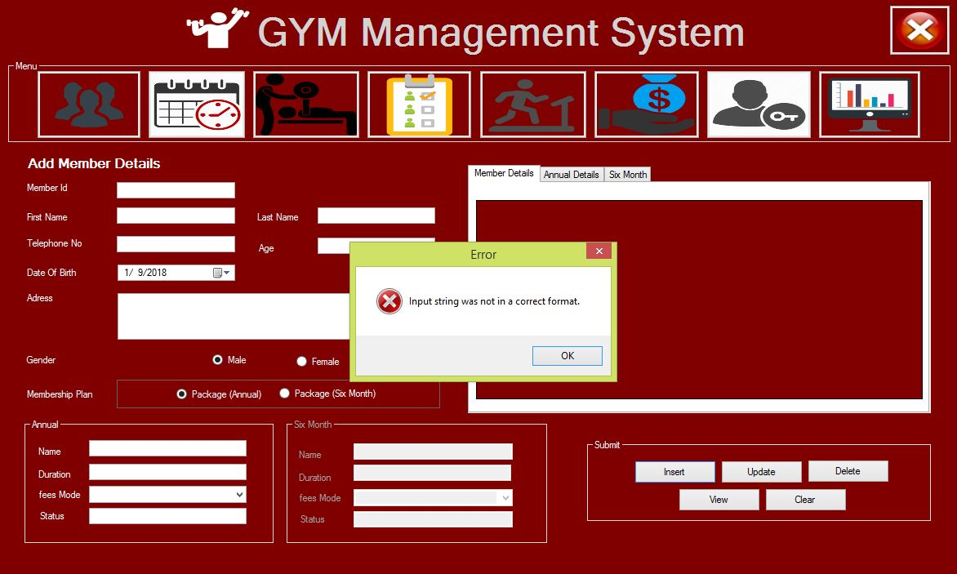

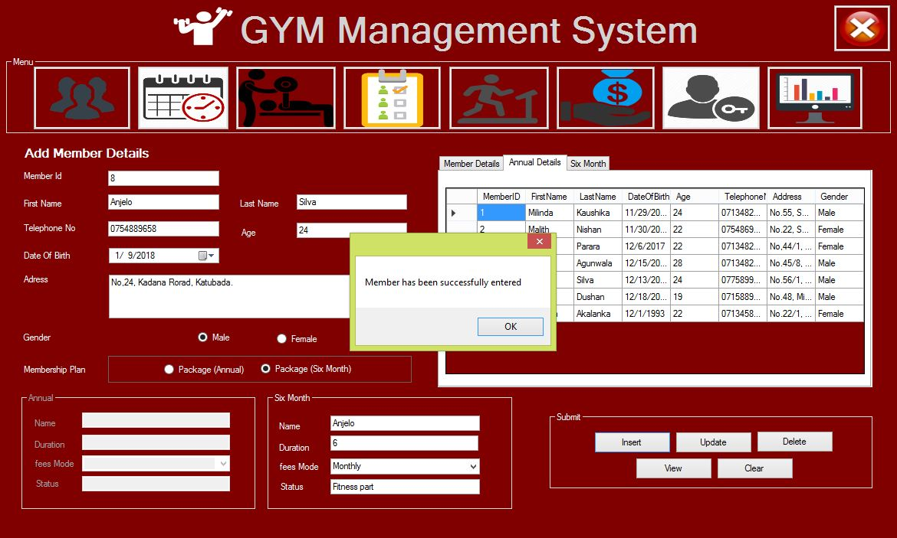

**Test case 3 execution**

* **Test case 3 – Trainer Information.**

|  |  |  |  |  |  |  |  |
| --- | --- | --- | --- | --- | --- | --- | --- |
| **Test Case #** | **Condition** | **Test Execution step** | **Expected Result** | **Test Result** | **Date Tested** | **Tester** | **Comments** |
| TC0005 | Try to save the form without entering any field | 1. Go to Trainer Registration form 2. Press Save button | System should give an warning or it should show the missing fields. | F | 6-Oct-2017 | M |  |
| TC0006 | Try to Search  invalid member Id. | 1. Open Trainer registration form 2. Fill Member Id the required fields. 3. Press Button. | System should be display invalid massage. | F | 7-Oct-2017 | M |  |
| TC0007 | Save all required fields and cross check with database | 1. Open Trainer registration form 2. Fill out all the required fields 3. Press Save & Create Account. | System should save all required fields in the database. | P | 7-Oct-2017 | M |  |

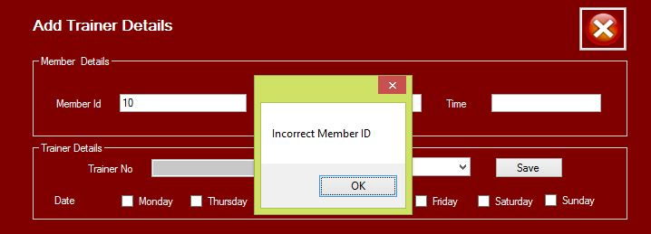

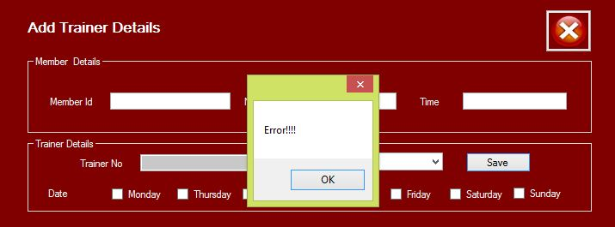

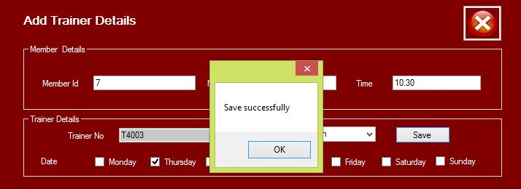

**Test case 4 execution**

* **Test case 4 – Payment Information.**

|  |  |  |  |  |  |  |  |
| --- | --- | --- | --- | --- | --- | --- | --- |
| **Test Case #** | **Condition** | **Test Execution step** | **Expected Result** | **Test Result** | **Date Tested** | **Tester** | **Comments** |
| TC0008 | Try to Search  valid member Id | 1. Open Payment registration form  2. Search by Payment ID | System should show valid data in the data grid view. | p | 7-Oct-2017 | M |  |
| TC0009 | Try to Search  invalid member Id | 1. Open Payment registration form  2. Search by Invalid Payment ID | System should show empty values in the data grid view. | p | 7-Oct-2017 | M |  |

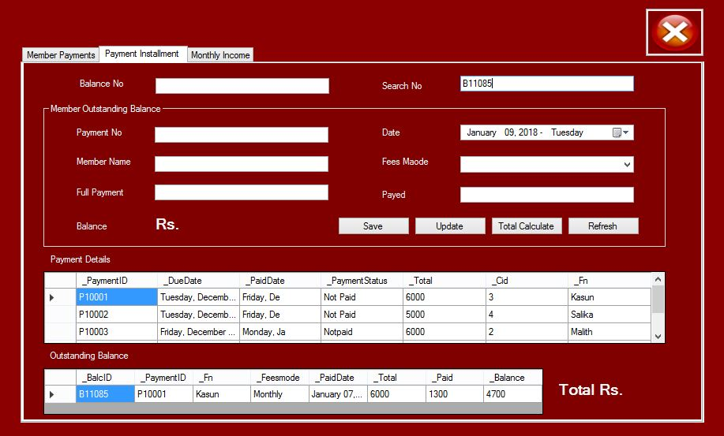

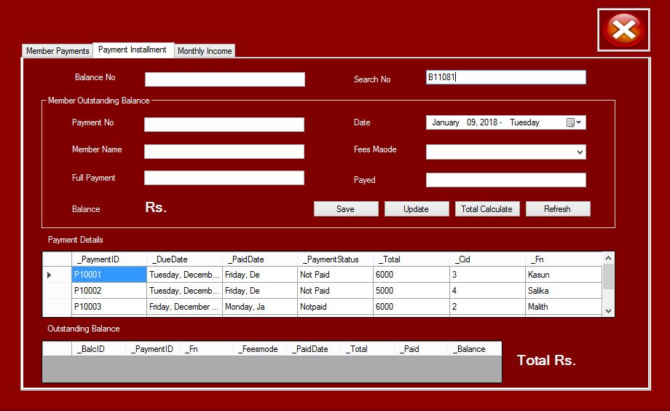

**Test case 4 execution**

* **Test case 5 – Monthly Income Information.**

|  |  |  |  |  |  |  |  |
| --- | --- | --- | --- | --- | --- | --- | --- |
| **Test Case #** | **Condition** | **Test Execution step** | **Expected Result** | **Test Result** | **Date Tested** | **Tester** | **Comments** |
| TC0010 | Test the find monthly Income values. | 1. Select Balance Table.  2. Search by Monthly Wise. | “January”, were displayed on the data grid view. | p | 7-Oct-2017 | M |  |
| TC0011 | Use two different months and try to find the record | 1. Select Balance Table.  2. Search by any months. | System should show empty values in the data grid view. | p | 7-Oct-2017 | M |  |

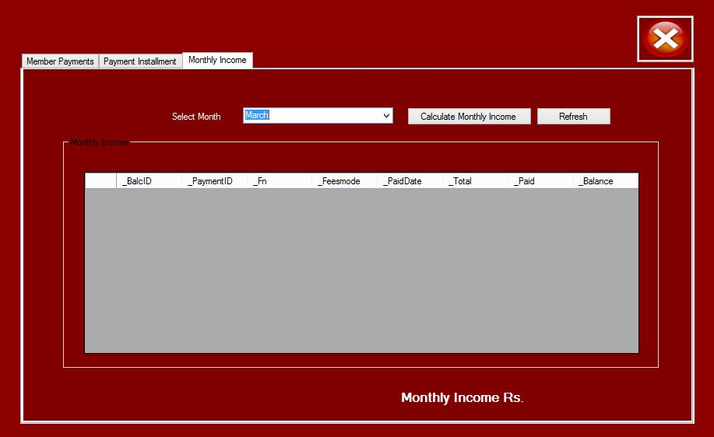

**Test case 5 execution**

* **Test case 5 – Member Payment Report Information.**

|  |  |  |  |  |  |  |  |
| --- | --- | --- | --- | --- | --- | --- | --- |
| **Test Case #** | **Condition** | **Test Execution step** | **Expected Result** | **Test Result** | **Date Tested** | **Tester** | **Comments** |
| TC0012 | Member ID is the reference for generating resource report  . | 1. Select Balance Table.  2. Search by Balance Id. | Should also be displayed on the member payment in the Report viewer. | p | 7-Oct-2017 | M |  |
| TC0011 | Find the Invalid Member Details. | 1. Select Balance Table.  2. Search by invalid Balance Id. | System should show empty values in the data grid view. | p | 7-Oct-2017 | M |  |



**1.17 Detailed Properties and Method Information**

**Member class**

**Member class - properties and methods description.**

|  |  |
| --- | --- |
| **Properties** | |
| **Property** | **Description** |
| private string _memberID; | Unique ID allocated for the member |
| private string _firstName; | Fist Name of the member |
| private string _lastName; | Last Name of the member |
| private string _dateOfBirth; | Date of birth of the member |
| private int _age; | Age of the member |
| private string _telephoneNo; | Contact number of the member |
| private string _address; | Address of the member |
| private string _gender; | Gender of the member |
| **Methods** | |
| **Method** | **Description** |
| public virtual bool register() | Method for inserting member information into the database. Member object is received as the parameter and Boolean result is returned |
| public virtual bool updatemembers() | Method for updating existing member information in the database. Member object is received as the parameter and Boolean result is returned |
| public virtual bool deletemembers() | Method for deleting an existing member. Member object is received as the parameter and Boolean result is returned |
| public member findmemberById(string Id) | Method for searching the details of a particular member by providing the member ID. Member object includes a member ID is received and Member object with member information is returned |
| public List<member>getAllmemberdetails() | This method is for searching all the member records in Member table in the database. No parameters received and a Member object typed List is returned. | |

**Category of member Annual class**

**Annual class - properties and methods description.**

|  |  |
| --- | --- |
| **Properties** | |
| **Property** | **Description** |
| private string _currentMember; | Fist Name of the member |
| private int _duration; | Member Duration. |
| private string _fees; | Member Fees Mode. |
| private string _status; | Member States. |
| **Methods** | |
| **Method** | **Description** |
| public override bool register() | Method for inserting member information and annual details into the database. |
| public override bool updatemembers() | Method for updating existing member information & annual details in the database. |
| public virtual bool deletemembers() | Method for deleting an existing member. Member object is received as the parameter and Boolean result is returned |

**Category of member Six Monthly class**

**Monthly class - properties and methods description.**

|  |  |
| --- | --- |
| **Properties** | |
| **Property** | **Description** |
| private string _currentMember; | Fist Name of the member |
| private int _duration; | Member Duration. |
| private string _fees; | Member Fees Mode. |
| private string _status; | Member States. |
| **Methods** | |
| **Method** | **Description** |
| public override bool register() | Method for inserting member information and annual details into the database. |
| public override bool updatemembers() | Method for updating existing member information & annual details in the database. |
| public virtual bool deletemembers() | Method for deleting an existing member. Member object is received as the parameter and Boolean result is returned |

**Attendance** **class**

**Attendance class - properties and methods description.**

|  |  |
| --- | --- |
| **Properties** | |
| **Property** | **Description** |
| private string attendanceID; | Unique ID allocated for the attendance. |
| private string scheduleID; | Schedule ID to which the attendance are related |
| private string memberName; | Fist Name of the member |
| private string trainer; | Trainer of the member |
| private string date; | Attendance Date |
| private string time; | Attendance Time |
| private string present; | Member Present or Absent |
| **Methods** | |
| **Method** | **Description** |
| public bool addAttendance() | Method for inserting member attendance information into the database. Attendance object is received as the parameter and Boolean result is returned. |
| public List<Attendance> getAllattendancedetails() | This method is used for searching all the loan information. No parameters received and a Loan object typed List is returned |

**Equipment class**

**Equipment class - properties and methods description.**

|  |  |
| --- | --- |
| **Properties** | |
| **Property** | **Description** |
| private string _equipID; | Unique ID allocated for the attendance. |
| private string _equipName; | Schedule ID to which the attendance are related |
| private double _price; | Fist Name of the member |
| **Methods** | |
| **Method** | **Description** |
| public bool addNewEquipments() | Method for inserting equipment information into the database. Equipment object is received as the parameter and Boolean result is returned. |
| public List<Equipment> getAllEquipment() | This method is used for searching all the loan information. No parameters received and a equipment object typed List is returned |
| public Equipment findAEquipmentById(string Id) | Method used for searching equipment information by Equipment ID. Equipment object which consists of an equipment ID is received as the parameter and a equipment object typed List is returned. |

**Trainer class**

**Trainer class - properties and methods description.**

|  |  |
| --- | --- |
| **Properties** | |
| **Property** | **Description** |
| private string trainerID; | Unique ID allocated for the trainer. |
| private string date; | Trainer Date |
| private string trainername; | Name of the Trainer |
| private string cid; | Member ID to which the trainer are related. |
| private string name; | Name of the member |
| private string time; | Trainer Time |
| **Methods** | |
| **Method** | **Description** |
| public bool registertrainer() | Method for inserting trainer information into the database. Trainer object is received as the parameter and Boolean result is returned. |
| public Trainer findTrainerById(string Id) | Method for inserting trainer information into the database. Trainer object is received as the parameter and Boolean result is returned. |

**Payment Balance class**

**Payment Balance class - properties and methods description.**

|  |  |
| --- | --- |
| **Properties** | |
| **Property** | **Description** |
| private string balcID; | Unique ID allocated for the Balance. |
| private string paymentID; | Payment ID to which the Balance are related. |
| private string fn; | Name of the Member |
| private string feesmode; | Member Fees Mode. |
| private string paidDate; | Payment date. |
| private double total; | Total Payments. |
| private double paid; | Member played |
| private double balance; | Payment balance. |
| **Methods** | |
| **Method** | **Description** |
| public bool createPaymentbalance() | Method for inserting payment balance information into the database. Payment object is received as the parameter and Boolean result is returned. |
| public List<Paymentbalance> getAllPaymentsbalance() | This method is used for searching all the payment balance information. No parameters received and a payment object typed List is returned. |
| public List<Paymentbalance> getAllPaymentdate(string date) | Method used for searching payment balance information by balance date. Balance object which consists of an balance date is received as the parameter and a balance object typed List is returned. |
| public List<Paymentbalance> getAllPaymentID(string ID) | Method used for searching payment balance information by balance Id. Balance object which consists of a balance Id is received as the parameter and a balance object typed List is returned. |
| public bool updatePaymentbalance() | Method for update payment balance information and payment details into the database. |

**Schedule class**

**Schedule class - properties and methods description.**

|  |  |
| --- | --- |
| **Properties** | |
| **Property** | **Description** |
| private string scheduleID; | Unique ID allocated for the Schedule. |
| private string trainnerID; | Trainer ID to which the Schedule are related. |
| private string date; | Date of the Schedule |
| private string trainername; | Name of Trainer |
| private string name; | Name of Member |
| private string time; | Schedule Time |
| private string schedulstatus; | Schedule Status |
| **Methods** | |
| **Method** | **Description** |
| public bool registerSchedule() | Method for inserting Schedule balance information into the database. Schedule object is received as the parameter and Boolean result is returned. |
| public List<schedule> getAllScheduledetails() | This method is used for searching all the Schedule information. No parameters received and a Schedule object typed List is returned. |
| public bool Updateschedule() | Method for update Schedule information and Schedule details into the database. |
| public bool deleteschedule() | Method for deleting an existing Schedule. Schedule object is received as the parameter and Boolean result is returned. |
| public schedule findscheduleById(string Id) | Method used for searching Schedule information by Schedule Id. Schedule object which consists of an Schedule Id is received as the parameter and a Schedule object typed List is returned. |

**Data structures and algorithms used.**

* **Fine calculation algorithm**

This is a simple algorithm used for calculating the payment of fine which should be paid by a member when overdue payments are on time. We are following codes like this.

* **Source code – calculation all member payments**

int A = 0, B = 0;

for(A =0;A <dataGridView2.Rows.Count;++A)

{

B += Convert.ToInt32(dataGridView2.Rows[A].Cells[6].Value);

}

label21.Text = B.ToString();

* **Source code – calculation all member payments Balance.**

if (e.KeyChar == Convert.ToChar(Keys.Return))

{

try

{

double up = Convert.ToDouble(textfullpayment.Text);

double qua = Convert.ToDouble(textpayed.Text);

double tot = up - qua;

label15.Text = tot.ToString();

}

catch

{

clearText();

}

}

**1.18 User manual**

**User manual contents**

1. Logging in to the system

2. Navigating through menus button.

3. Registering for Members.

4 Searching and update all member information.

5. Registering an Attendance.

6. Member Appointments.

7. Monthly Income calculating.

8. Searching payment information.

9. Auto generating Reports.

1. Trainer Details.
2. Schedule Details
3. Equipment Details.

**User manual document**

* **logging in to the system**

1. Open the application and login form is displayed automatically.

2. I your credentials first and then click login button to access the system.

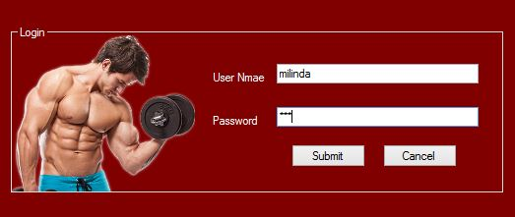

3. If your credentials are valid username and password then, will be displayed menu.

4. If your credentials are invalid, then following message will be displayed.

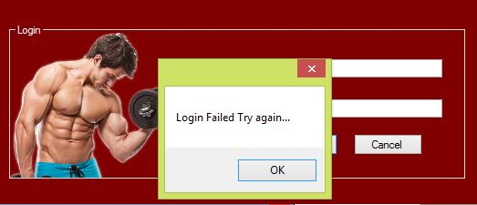

* **Navigating through buttons.**

1. Once you access the system, main menu will be appeared.

2. Click navigation button names to access different menus. Current menu name will be highlighted on the navigation bar.



* **Member Registering.**

3. Click Member button and then fill the required information in member information.

4. After inserting information click “Save” button.

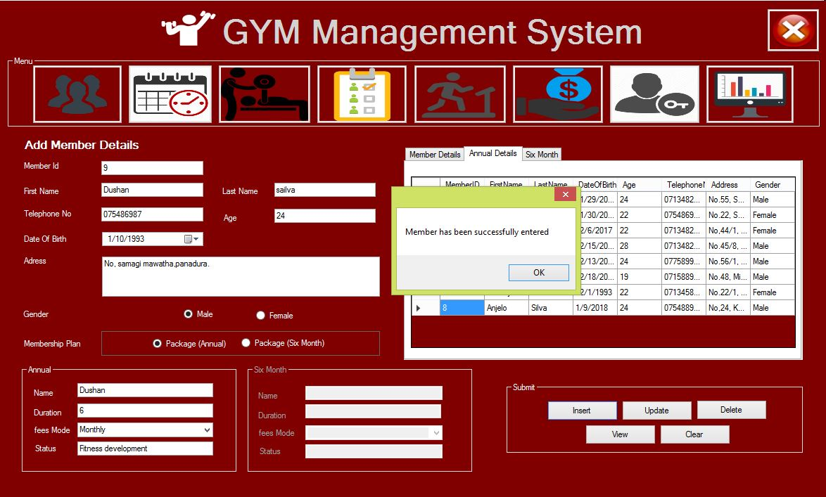

5. Then an information message will be displayed in order to ensure that the member information was saved. Message content is as follows.

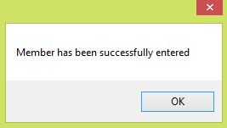

* **Member Payment Details.**

6. Click Payment button and then fill the required information in member payment information.

7. After inserting information click “Save” button.

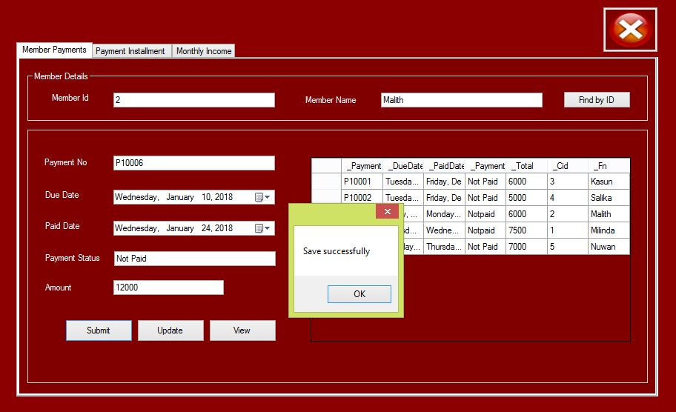

8. Then selecting a payment installment tab.

9. Then type payment id and press key then automatically display payment information.

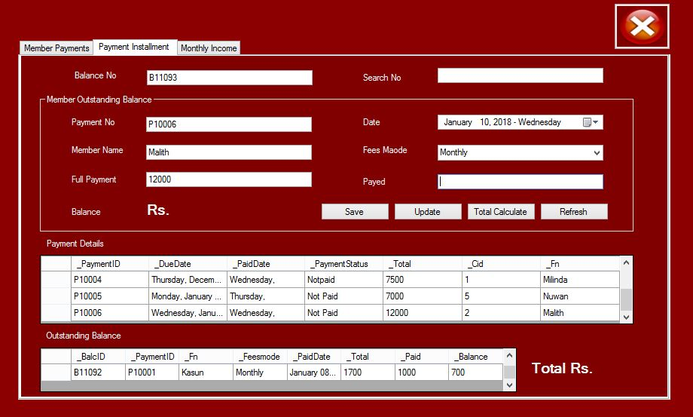

10. Then type payment balance in the paid text box and press the key then automatically display payment balance information.

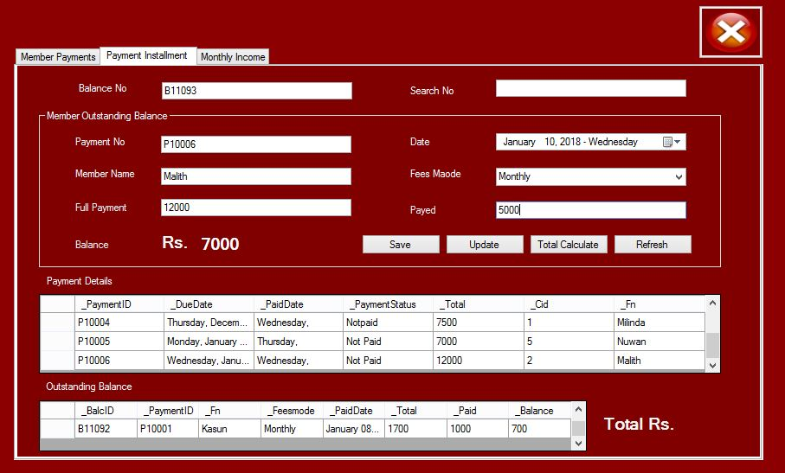

11. After inserting information click “Save” button.

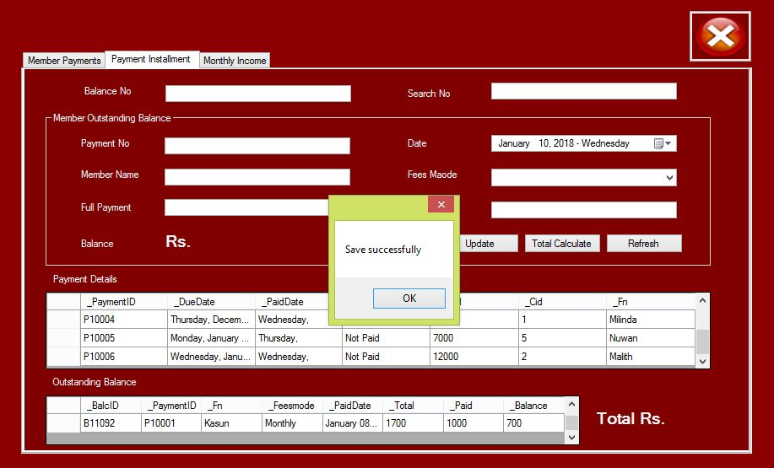

12. Update Member payment balance.

13. Select Order grid view and click row, then automatically display values in the text boxes.

14. Then update values and click update button.

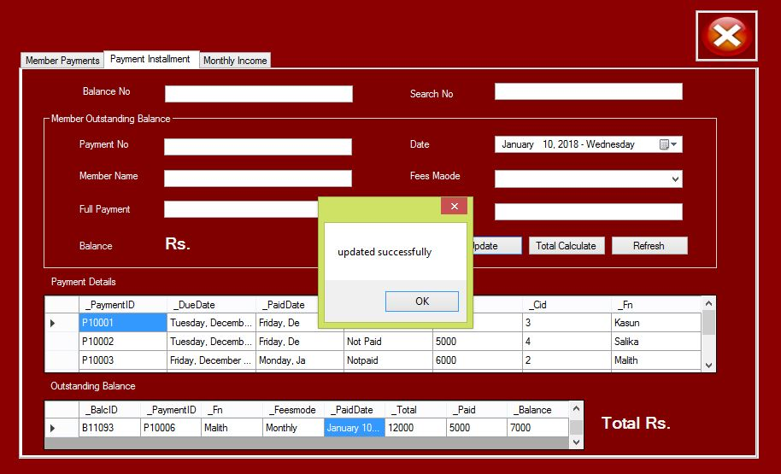

10. Then we find monthly member Income. Click Monthly income button.

11. Select month in the combo box, then automatically monthly payment information.

12. All total monthly income calculates.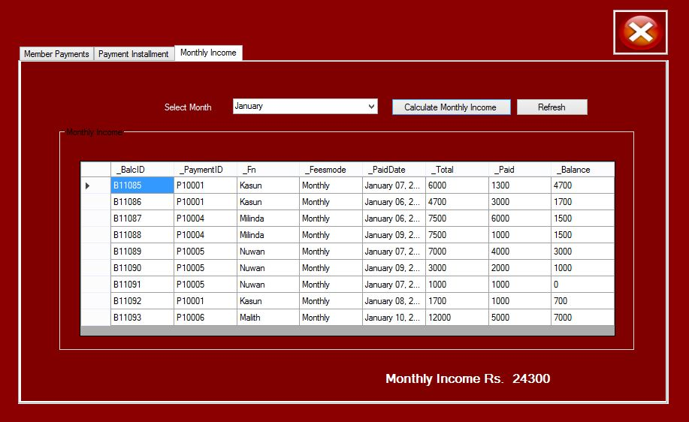

* **Member Equipment Details.**

13. Click Equipment button and then fill the required information in information.

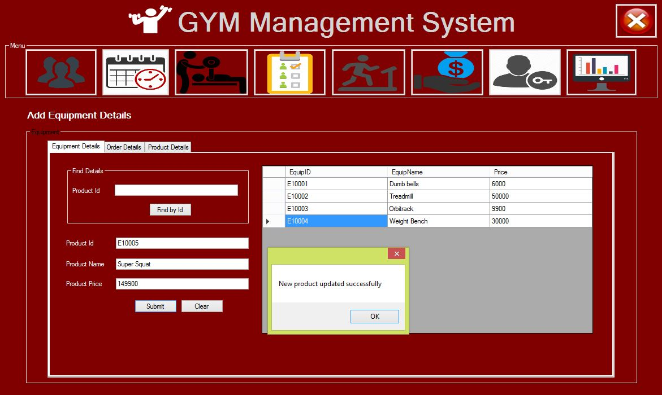

1. Click Equipment Order button and then fill the required information in information.

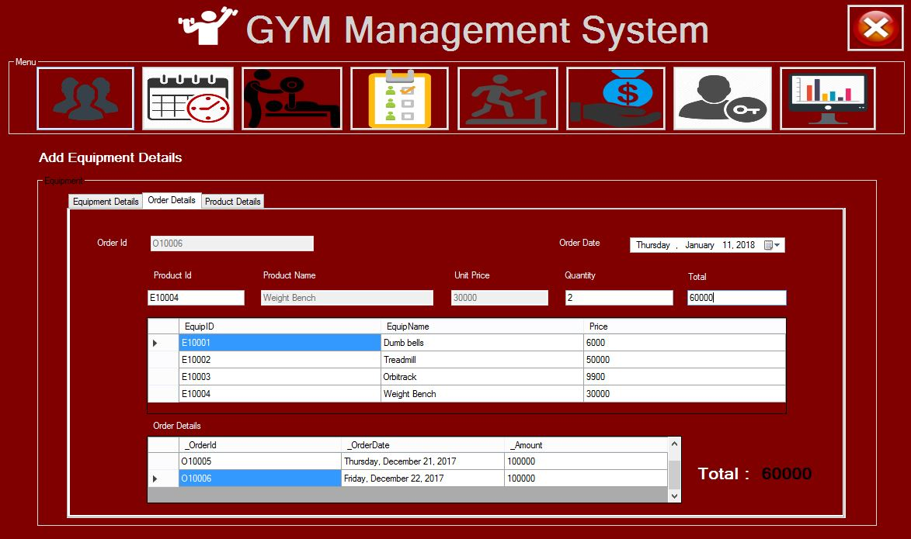

**1.18 Coding**

**Login Method.**

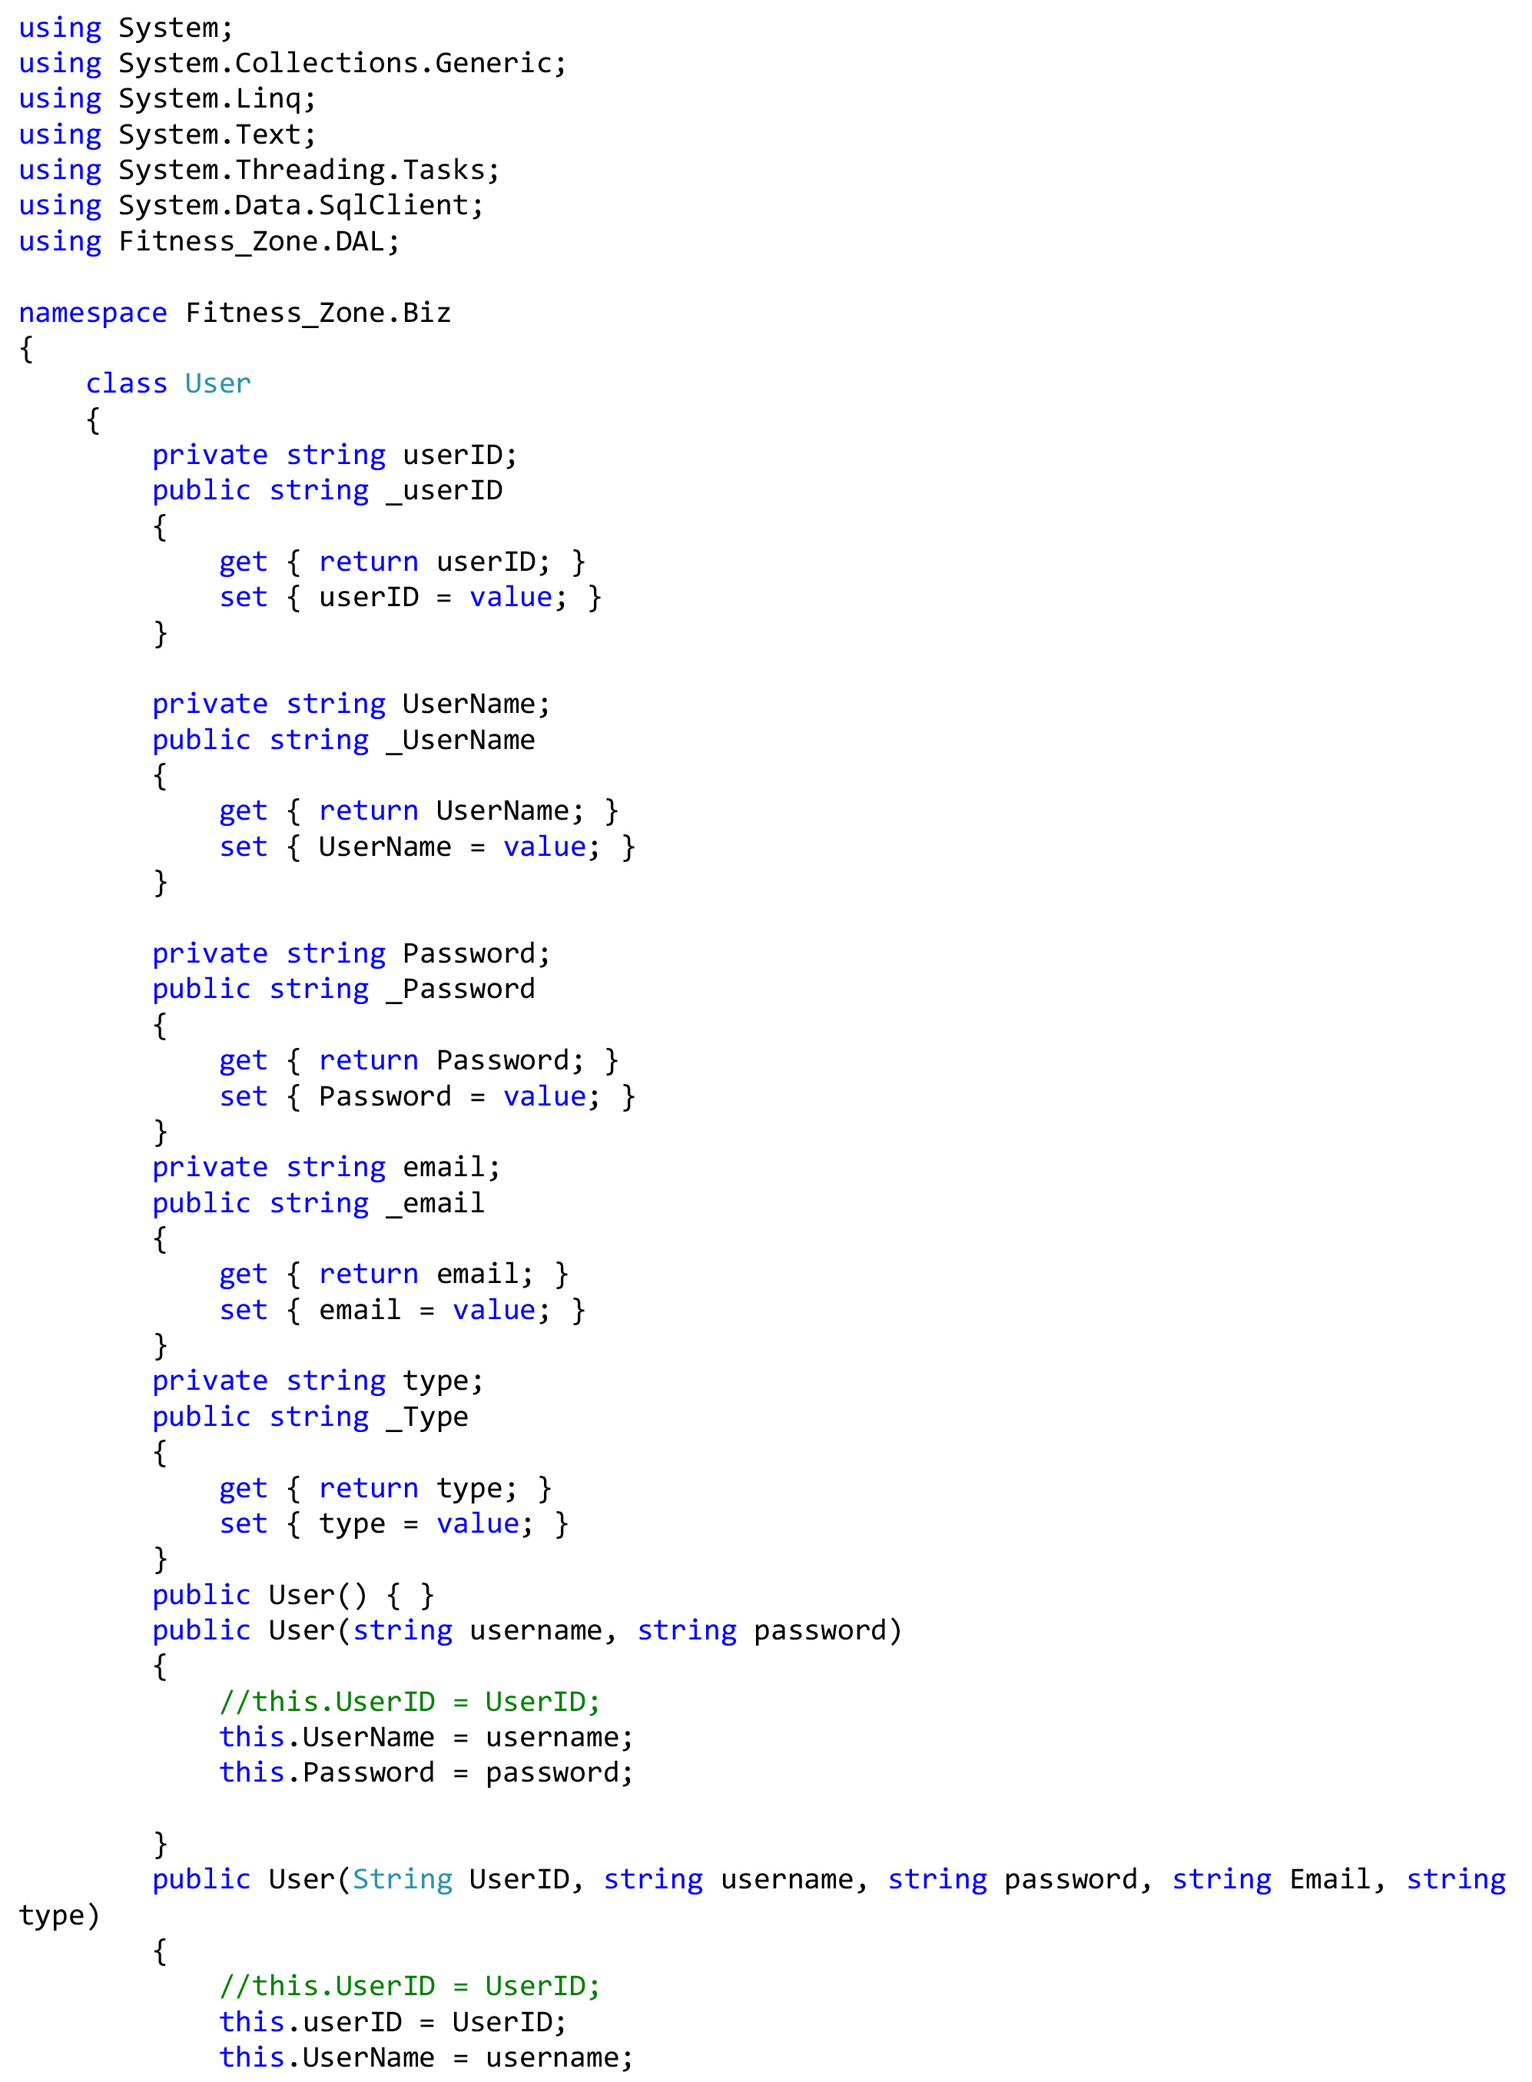

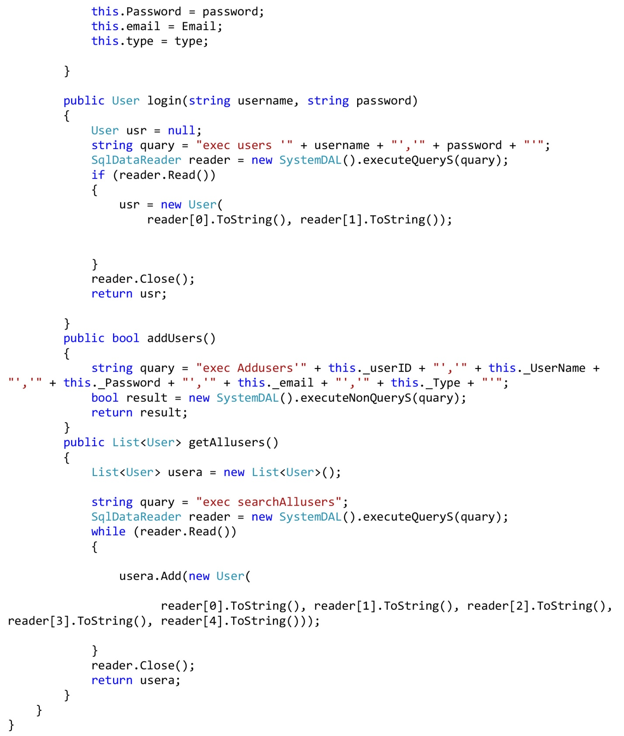

**Login Form.**

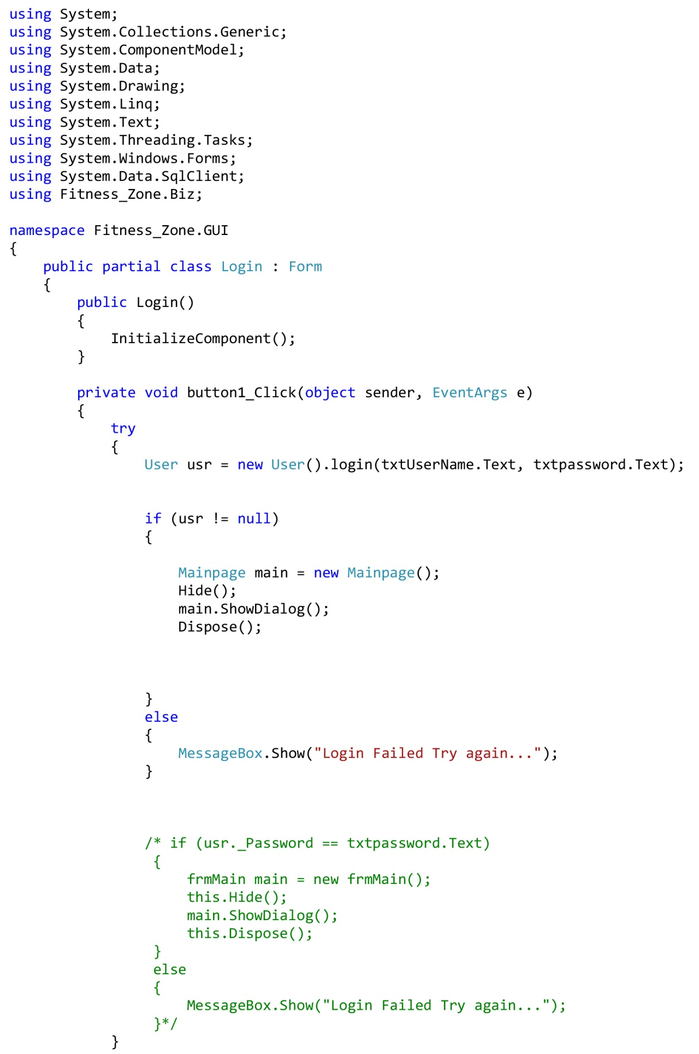

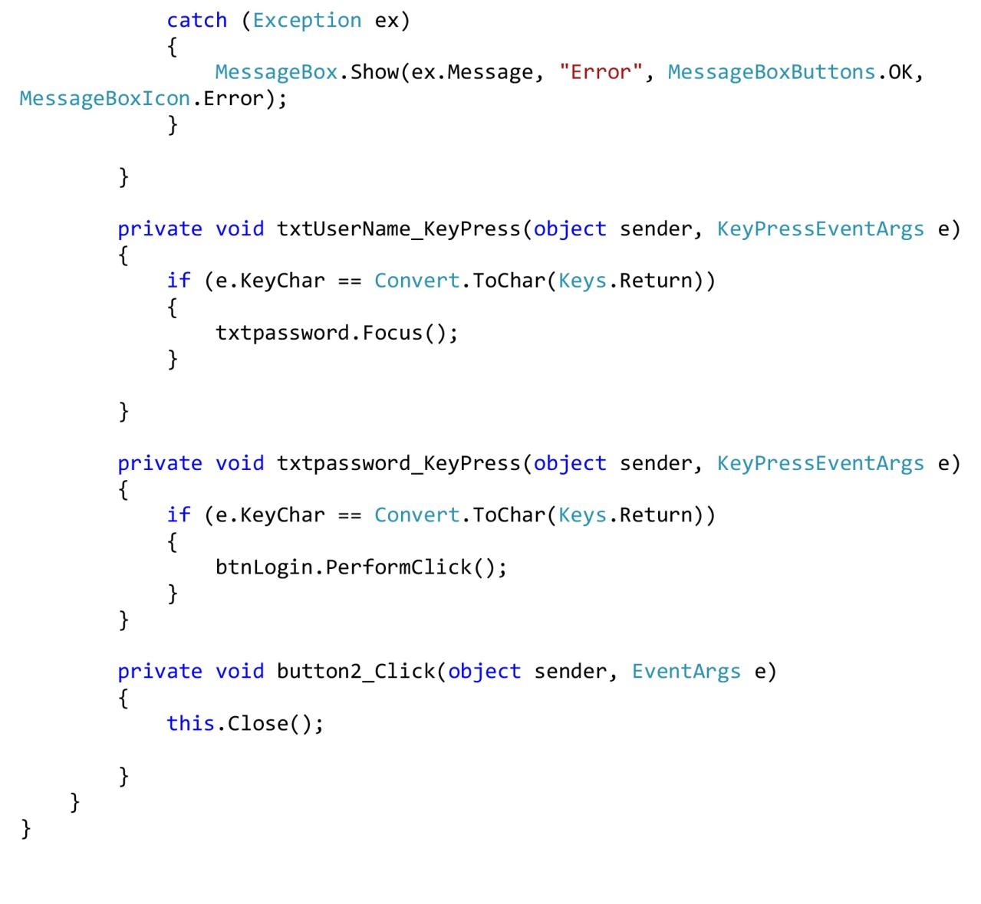

**Member Payment Method.**

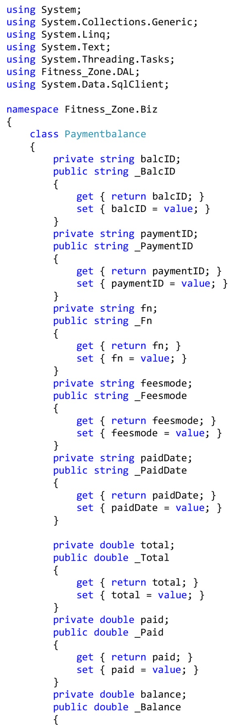

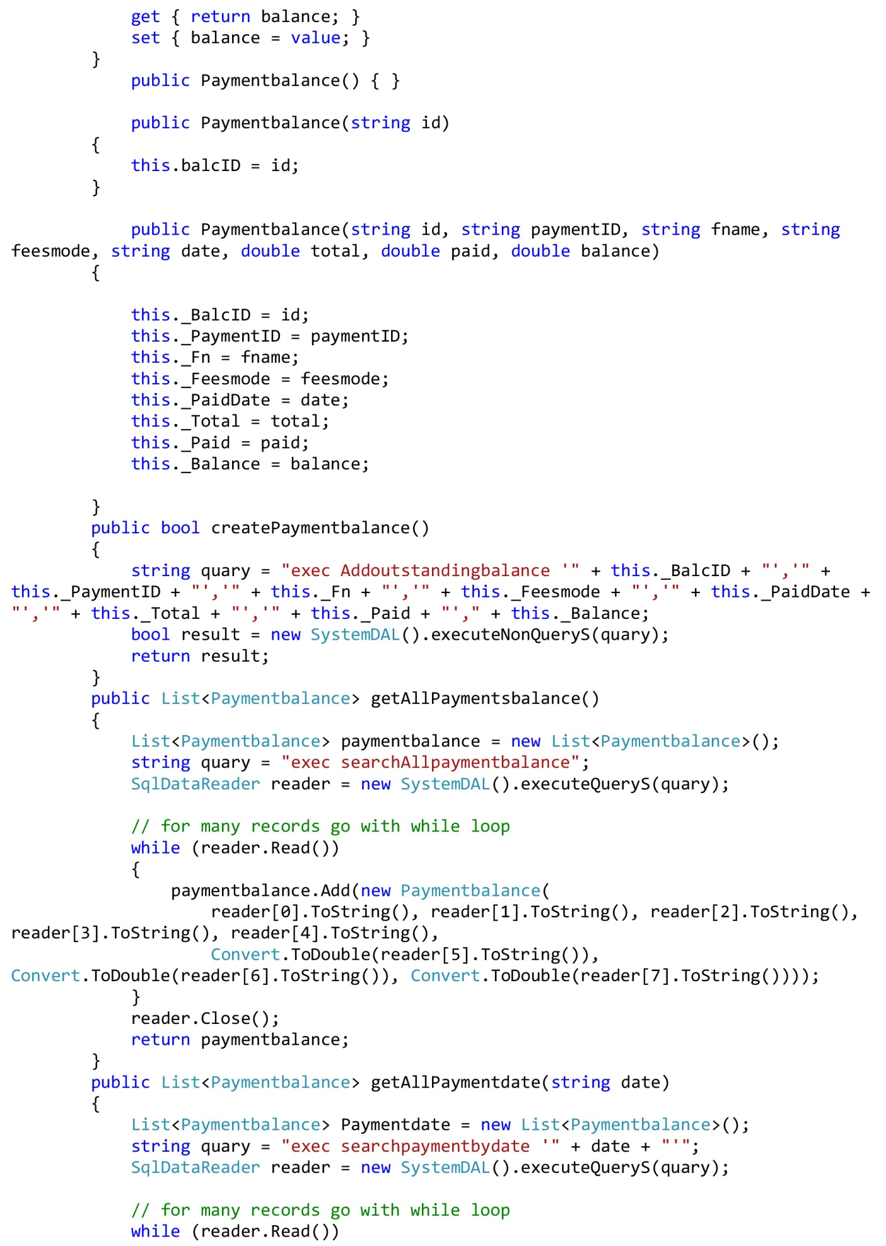

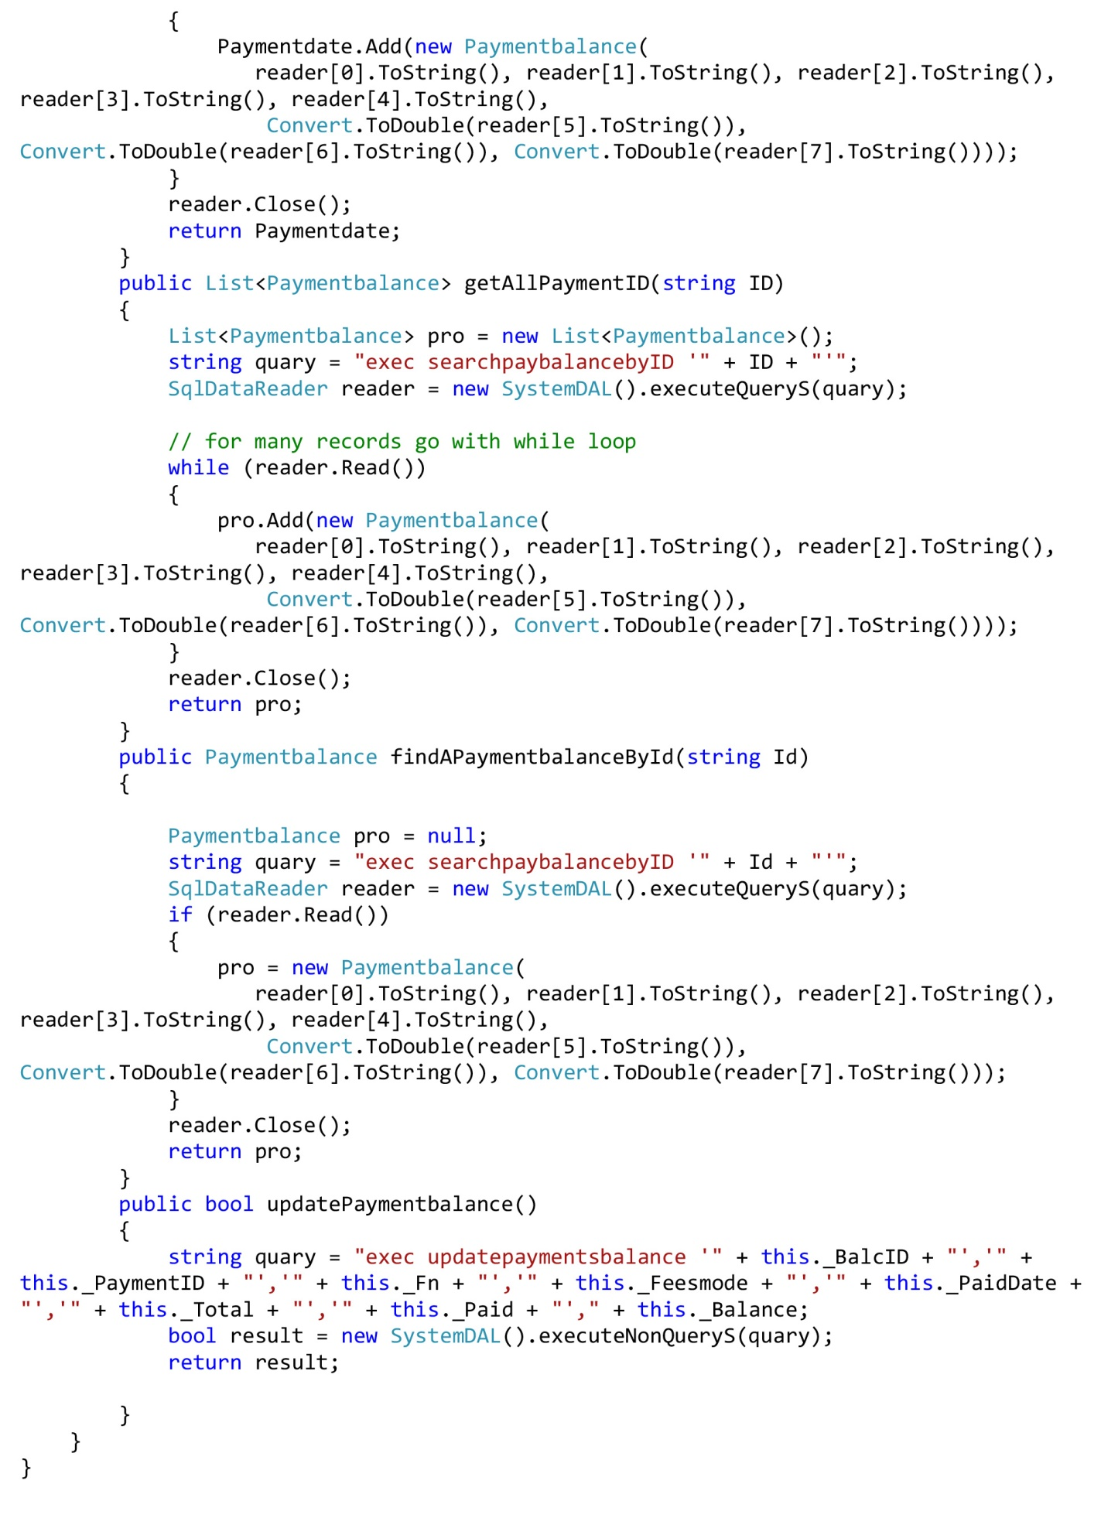

**Member Payment Form.**

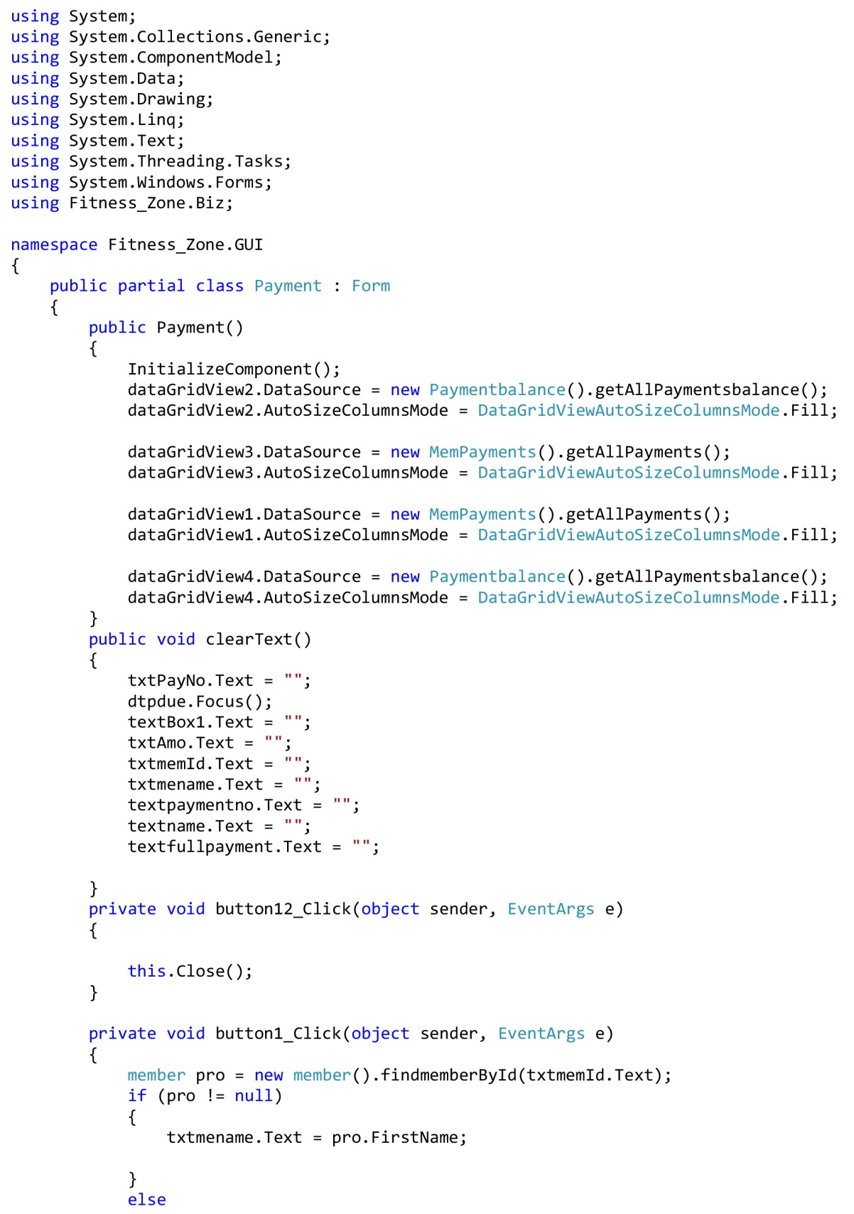

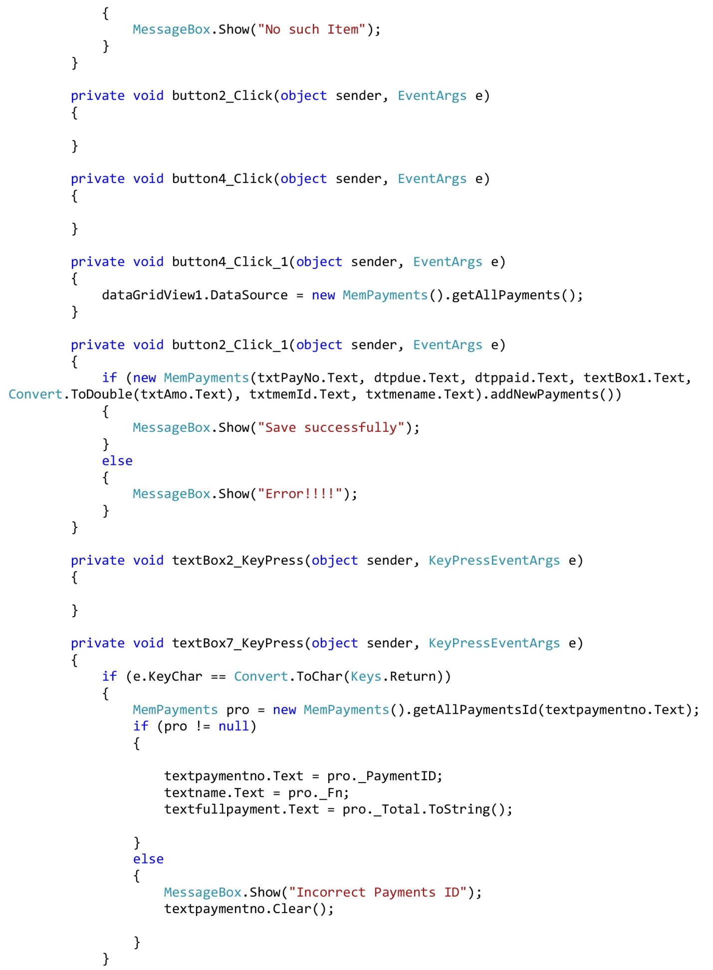

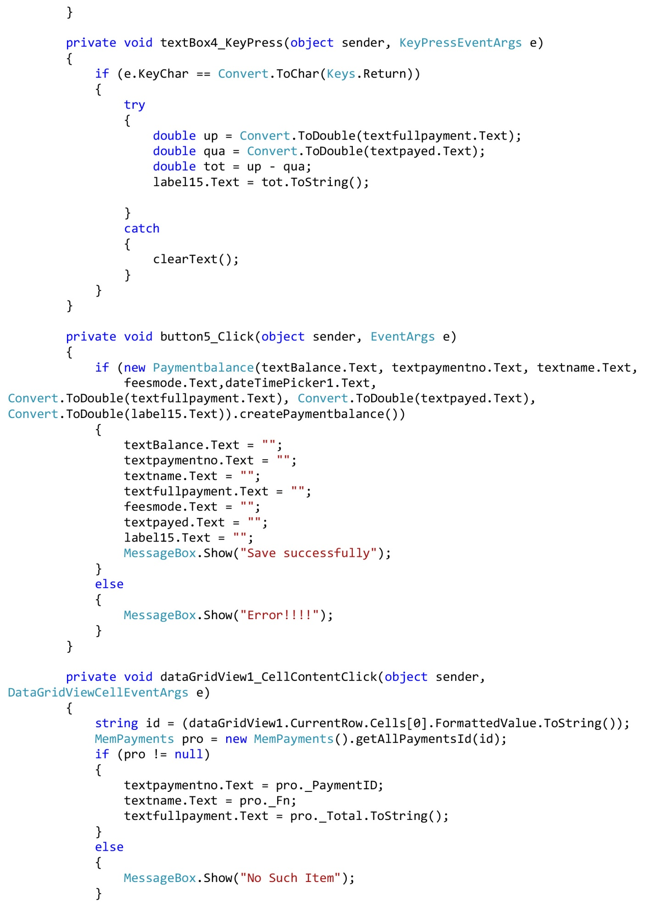

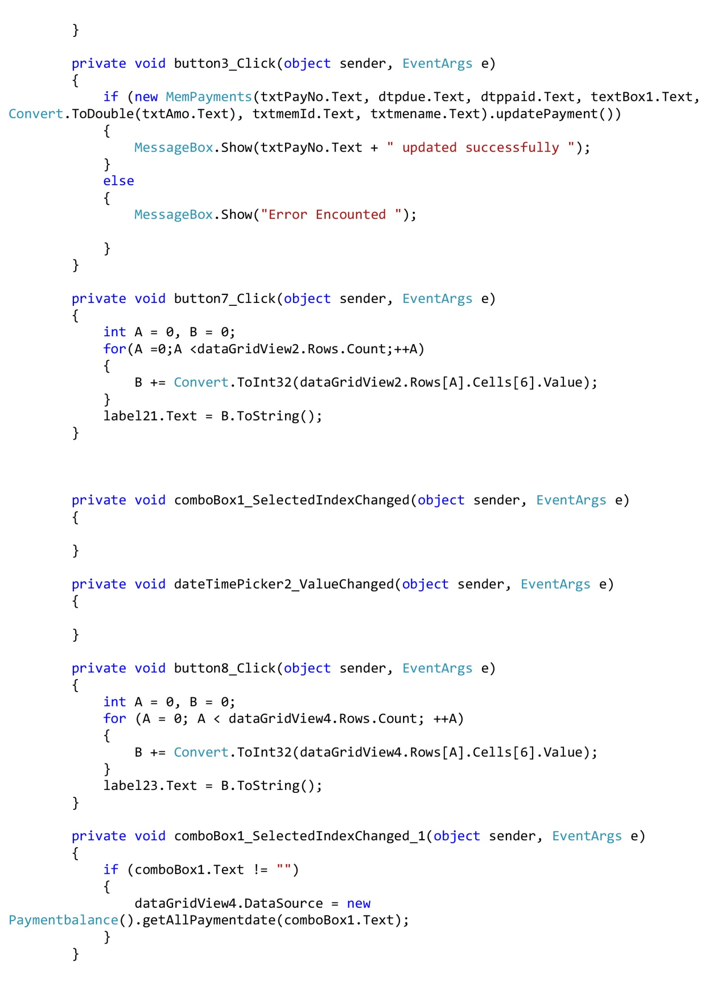

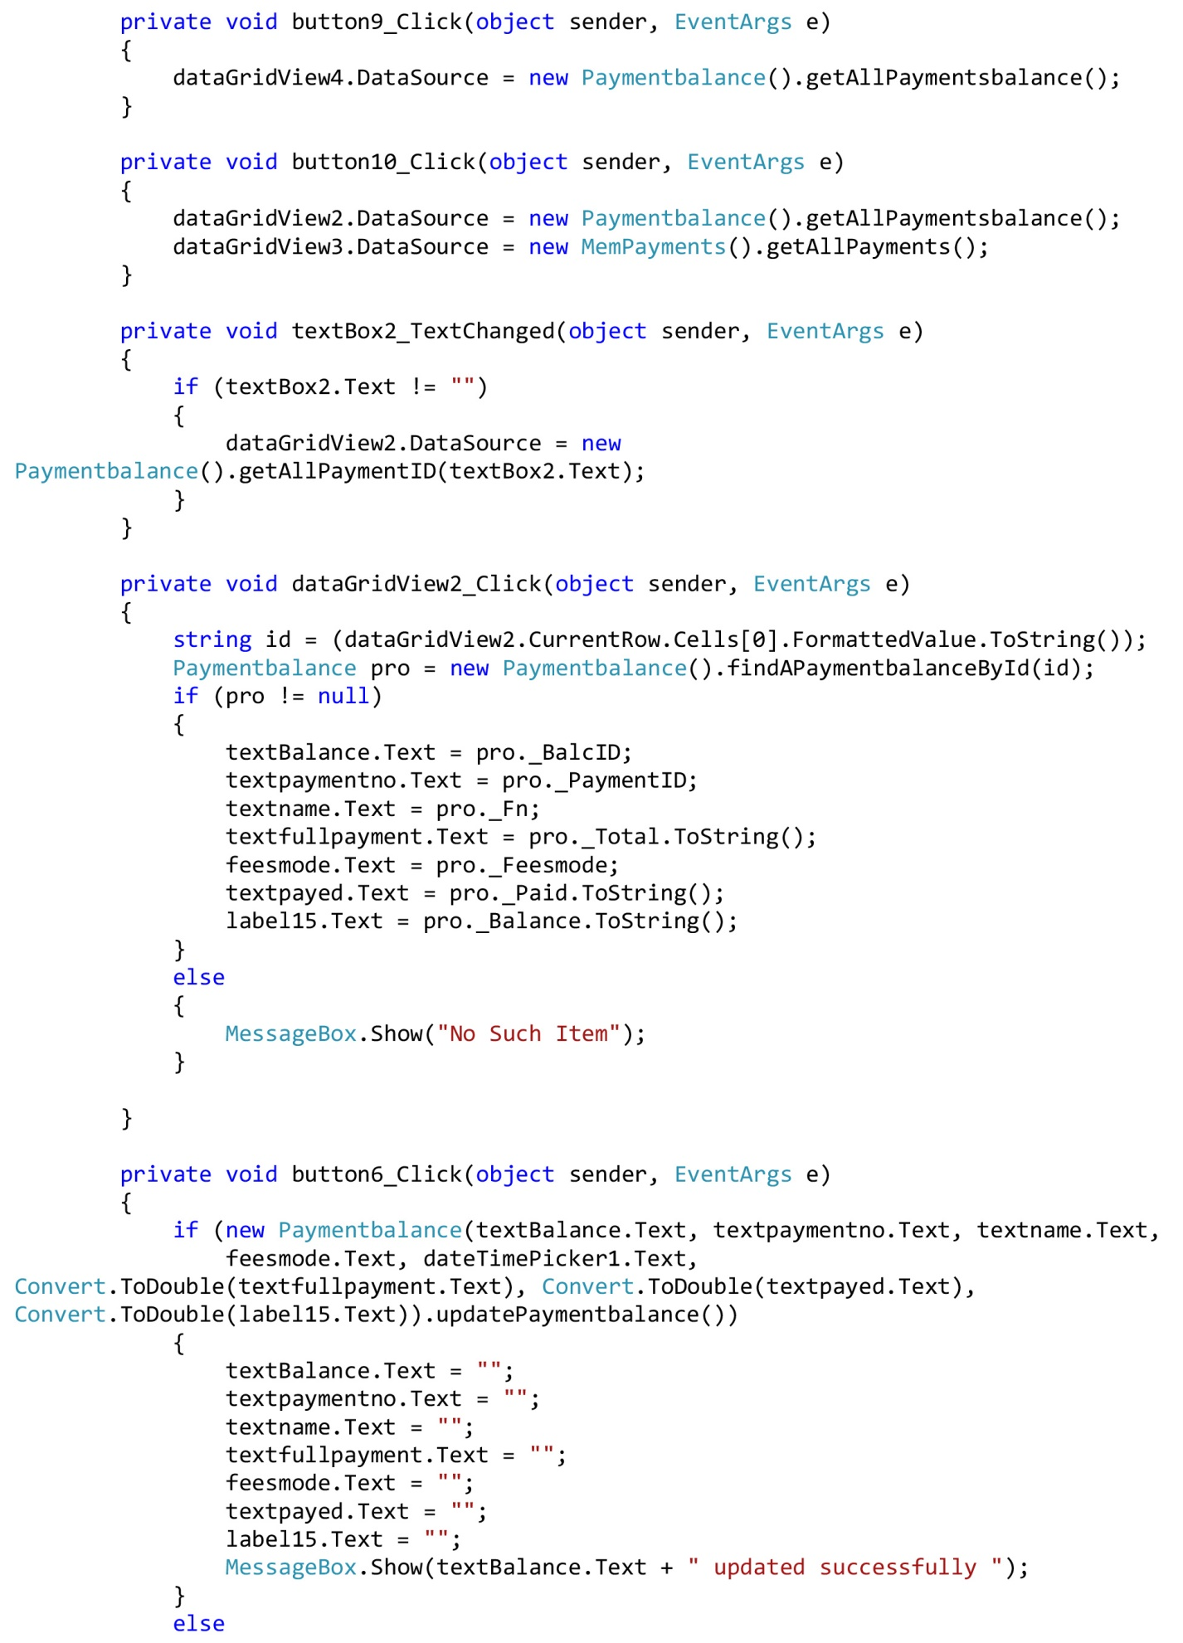

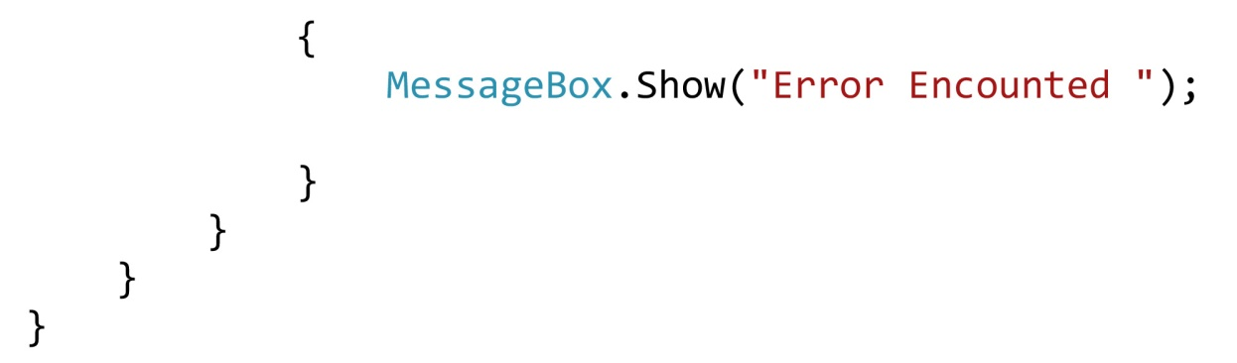

**Member Registration Method.**

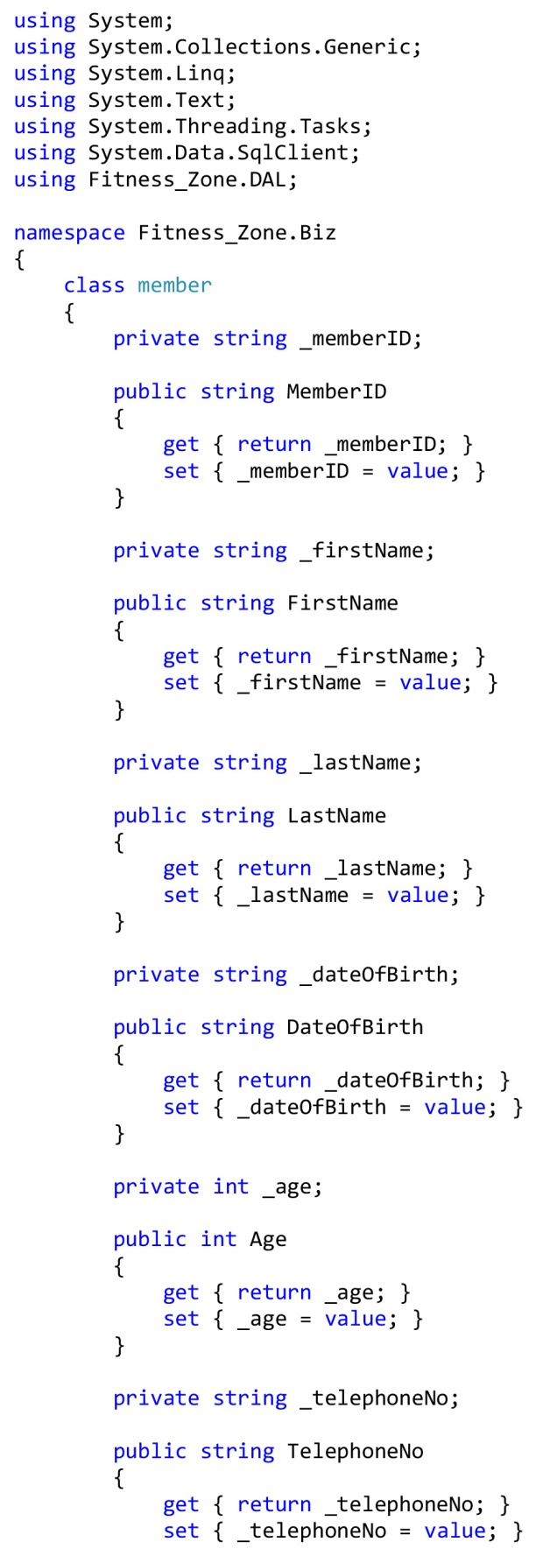

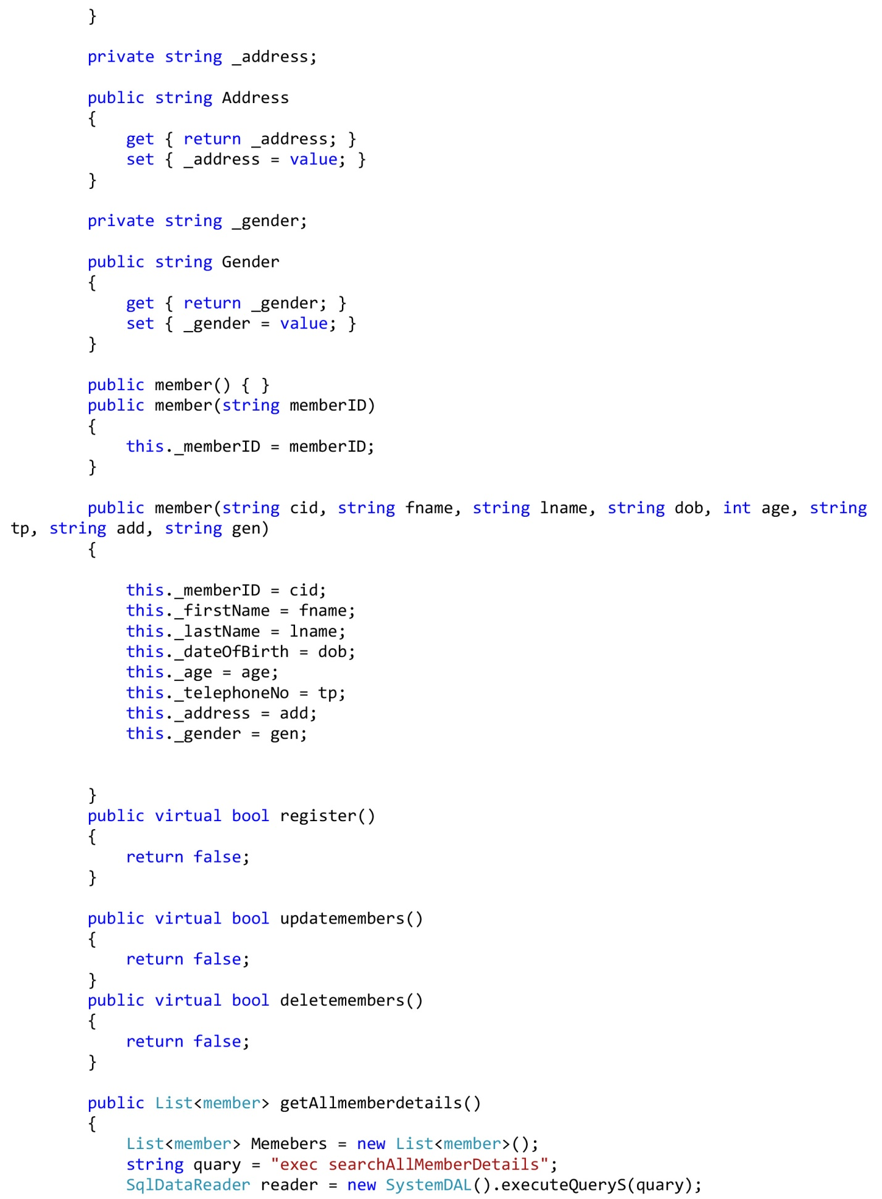

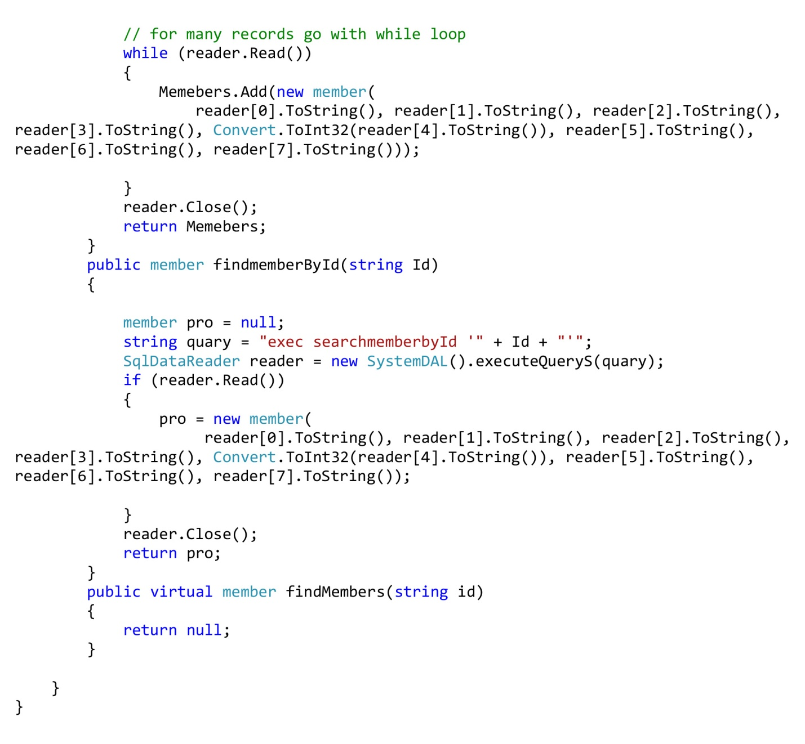

**Member Registration Form.**

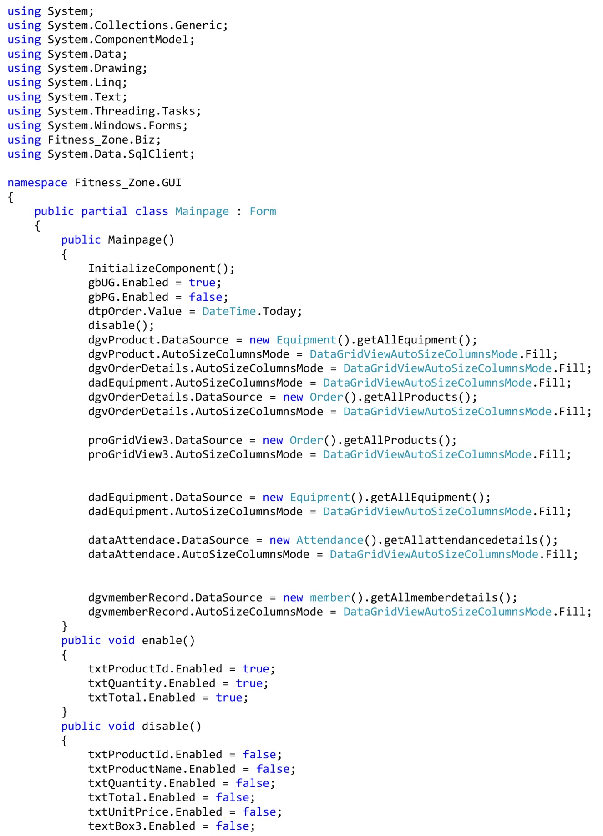

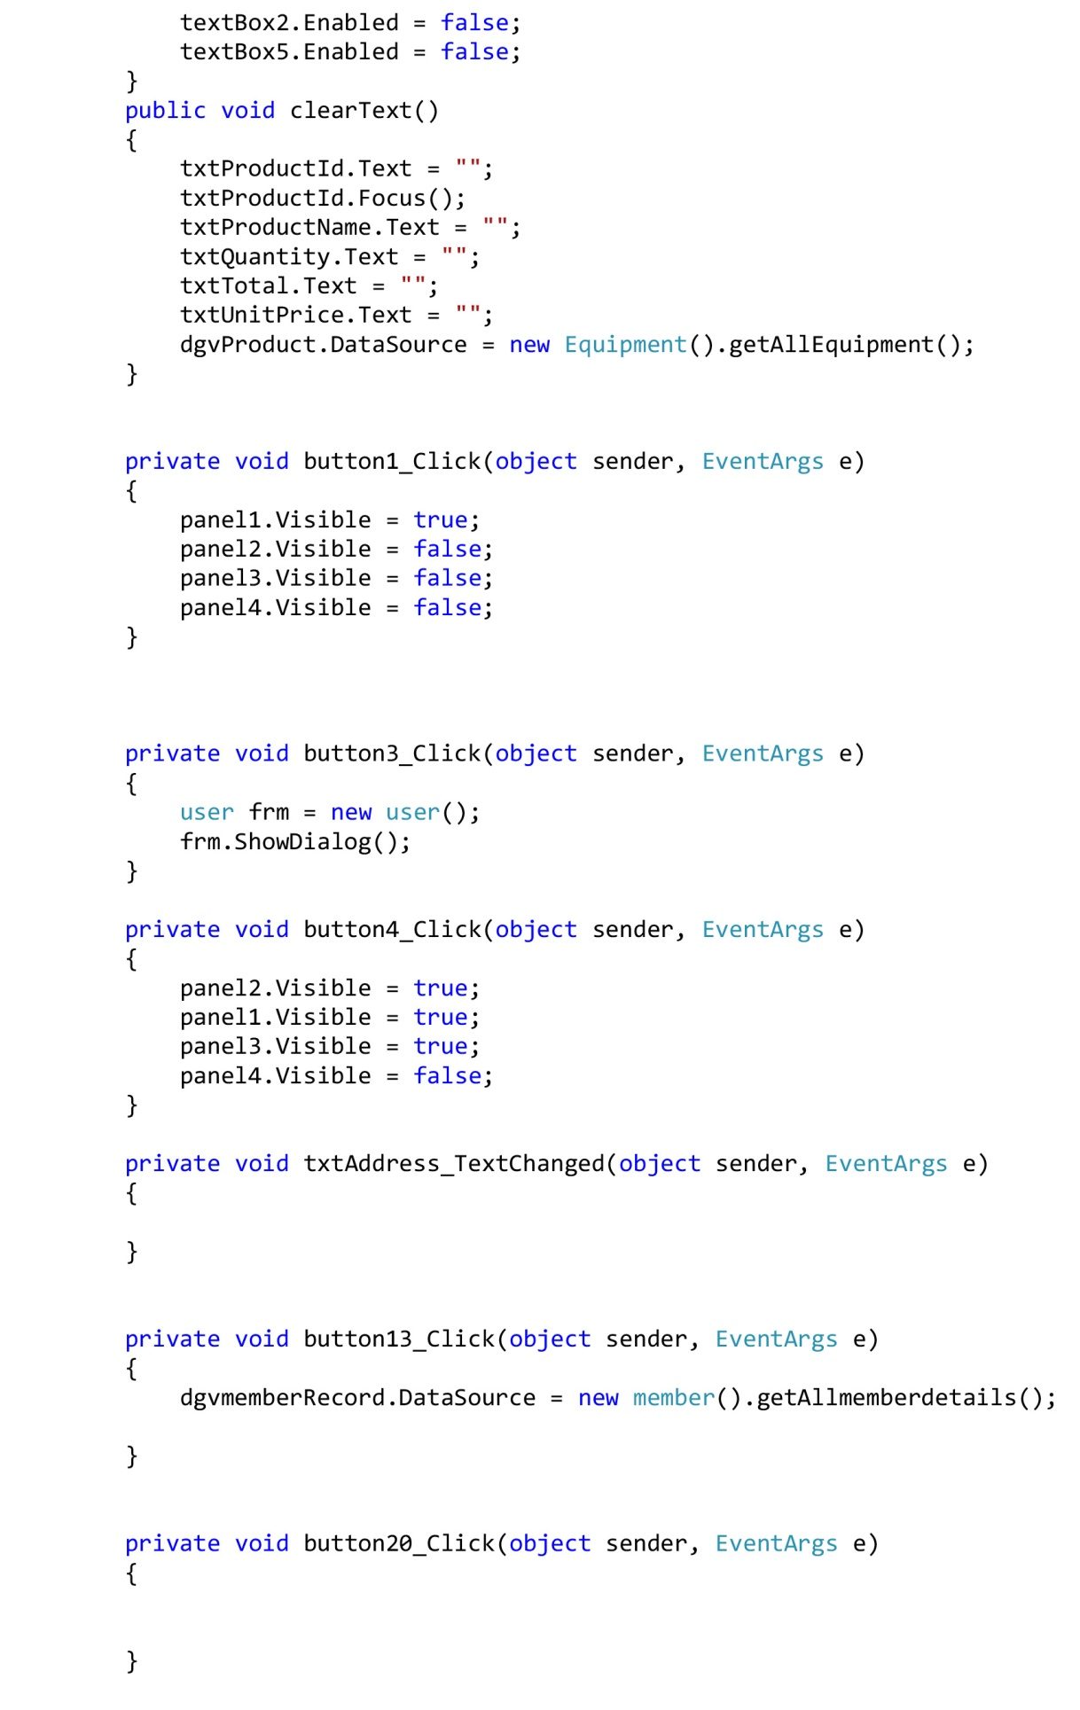

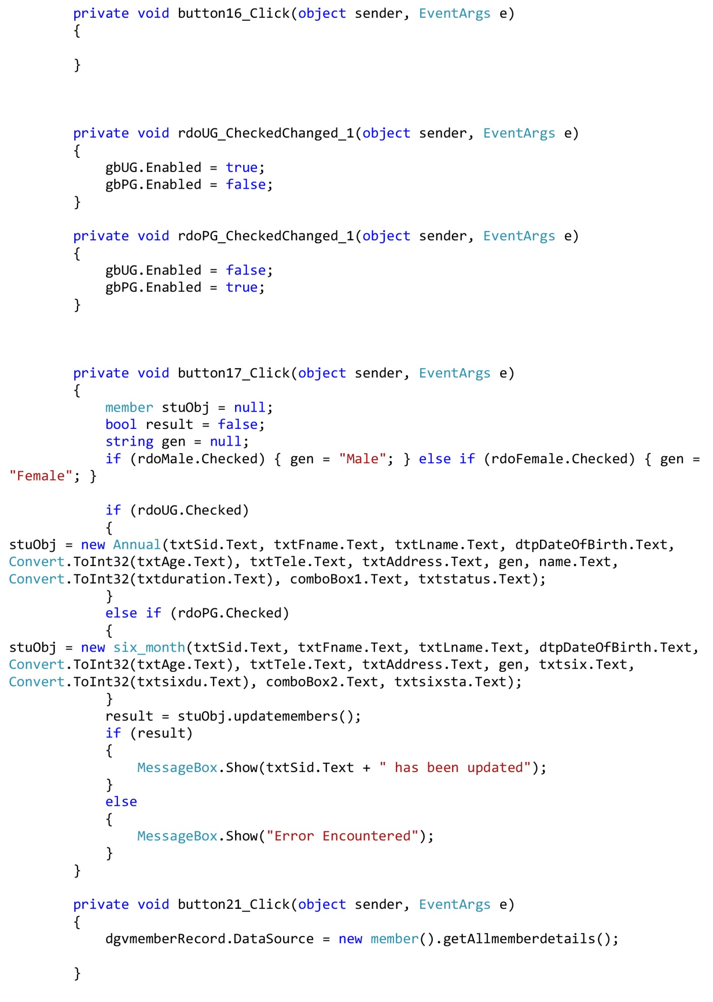

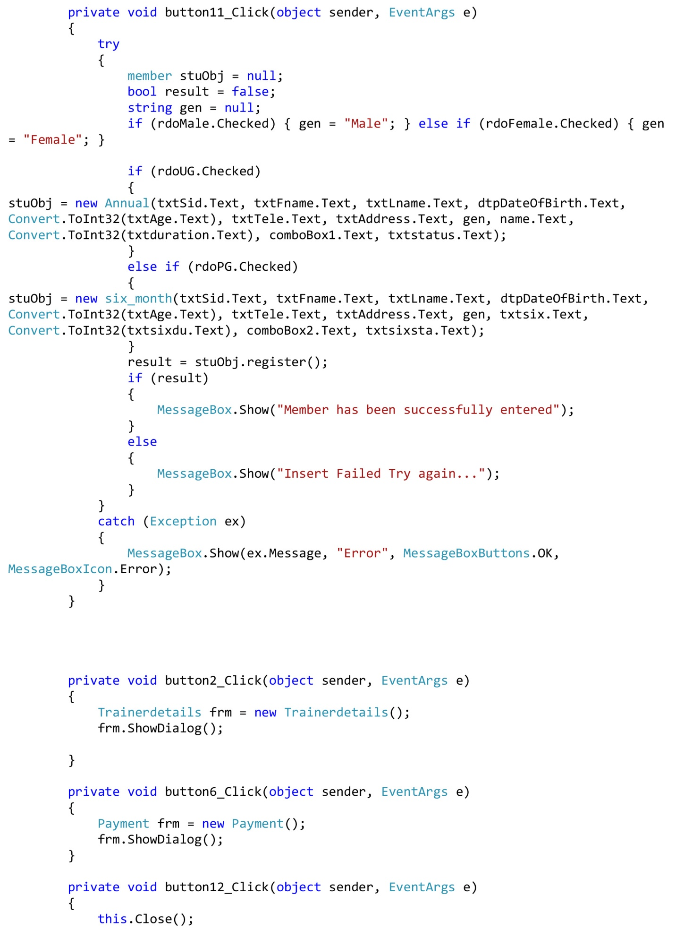

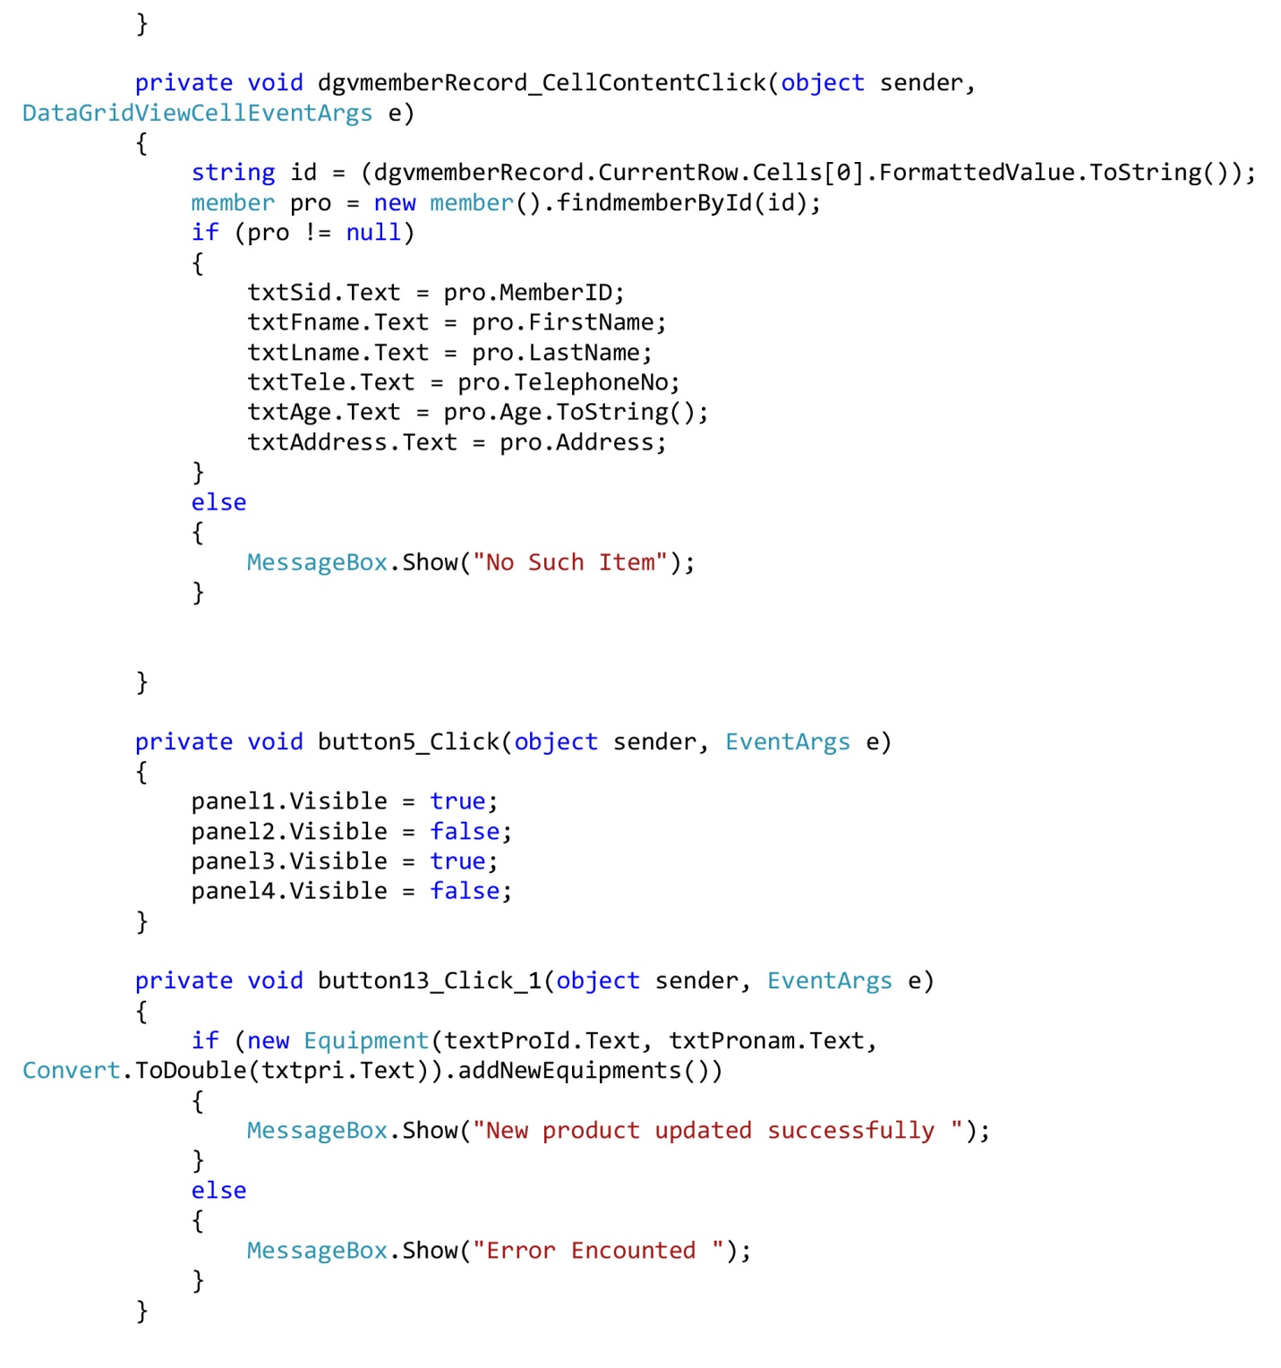

**1.19 System Maintenance & Evolution**

The maintenance activity consists of following tasks:

* Backup.
* Diagnostic.
* Integrity changes.
* Recovery.
* Design changes.

Performance tuning these features ensures the availability of the databases round the clock as the database maintenance is possible online when the system is in use. DBMS allows an online maintenance, rapid recovery and software based fault tolerance. The rapid recovery features allows the system administrator to provide ‘time’ to go back for the recovery of the data if the system fails due to power or network crash. Based on this time, system automatically goes back and collects all the changes and writes to disk

**1.20 Scope for Further Development**

The software has been developed in such a way that it cans accept modifications and further changes. The software is very user friendly and future any changes can be done easily. Software restructuring is carried out. Software restructuring modifies source code in an effort to make it amenable to future changes. In general, restructuring does not modify the overall program architecture. It tends to focus on the design details of individual modules and on local data structure defined within modules. Every system should allow scope for further development or enhancement. The system can be adapted for any further development. The system is so flexible to allow any modification need for the further functioning of programs. Since the objectives may be brought broad in future, the system can be easily modified accordingly, as the system has been modularized. The future expansion can be done in a concise manner in order to improve the efficiently of the system.

**1.21 CONCLUSION**

The “**GYM MANAGEMENT SYSTEM** (Fitness Zone)” is successfully designed and developed to fulfilling the necessary requirements, as identified in the requirements analysis phase, such as the system is very much user friendly, form level validation and field level validation are performing very efficiently. The new computerized system was found to be much faster and reliable and user friendly then the existing system, the system has been designed and developed step by step and tested successfully. It eliminates the human error that are likely to creep in the kind of working in which a bulk quantity of data and calculations as to be processed. The system results in quick retrieval of information that is very vital for the progress any organization. Cost is minimized in case of stationary. Burden of manual work is reduced as whenever transaction takes place, there is no need to record it in many places manually.

**1.22. References**

What is the object-oriented programming

http://searchmicroservices.techtarget.com/definition/object-oriented-programming-OOP/[ONLINE] [Accessed 4 December 2017].

object-oriented programming Objects, Classes & Methods http://study.com/academy/lesson/oop-object-oriented-programming-objects-classes-interfaces.html/[ONLINE] [Accessed 15 December 2017].

http://searchmicroservices.techtarget.com/definition/object-oriented-programming-OOP/[ONLINE] [Accessed 4 December 2017].

There are four types of object oriented programming concepts.

http://codebetter.com/raymondlewallen/2005/07/19/4-major-principles-of-object-oriented-programming/ [ONLINE] [Accessed 2 January 2017].